# STOCK ASSESSMENT AND MANAGEMENT ADVICE FOR BC PACIFIC HERRING: 2016 STATUS AND 2017 FORECAST

## Context

Fisheries and Oceans Canada (DFO) Pacific Fisheries Management Branch requested that DFO Pacific Science Branch assess the status of British Columbia (BC) herring stocks in 2016, and provide projections of potential herring abundance in 2017 and the consequences of a range of potential harvests to inform the development of the 2016/17 Integrated Fisheries Management Plan (IFMP).

Pacific Herring abundance is currently assessed using a statistical catch-age model. The catch-age model is fitted to commercial catch data, proportions-at-age data and a fishery-independent spawning biomass index to estimate biomass and recruitment and to generate 1-year forecasts of spawning biomass (Martell et al. 2012; DFO 2015a). Seven versions of the model are fitted, respectively, to data for five major stocks: Haida Gwaii (HG), Prince Rupert District (PRD), Central Coast (CC), Strait of Georgia (SOG) and West Coast Vancouver Island (WCVI), and two minor stocks: Area 2W and Area 27. A revised catch-age model was introduced for BC herring assessments in 2006 (Haist and Schweigert 2006), and the design of the model has since undergone several iterations that have re-structured various model components and addressed issues identified during peer-review. One major change introduced in 2011 (Martell et al. 2012) was setting the model to estimate the spawn dive survey scaling parameter *q2*, rather than setting it fixed at *q*2=1.0, as was done in previous assessment models. Another major change introduced in 2011 was to make the fishery cut-offs in the harvest control rule dependent on the model’s most recent estimate of unfished spawning biomass *SB*0 (i.e., cease fishing when the stock is estimated to be below 0.*25SB*0). In previous model iterations, the fishery cut-offs were fixed at absolute biomass levels estimated in 1996 (Schweigert et al. 1997). Throughout this document, the term Assessment Model 1 (AM1) describes the more recent management procedure (MP), which estimates the scaling factor for the surface survey *q*1 (1951-1987) and dive survey *q*2 (1988-2016) using informative priors; and uses estimated fishery cut-offs. Assessment Model 2 (AM2) refers to an approximation of the historical MP, in which the surface survey *q*1 (1951-1987) is estimated, the dive survey *q*2 (1988-2016) is fixed at 1.0 and the fishery cut-offs are fixed at 1996 levels.

There have been a number of requests to evaluate the potential consequences of applying AM1 vs. AM2 using simulation modelling. This reflects concerns that the consequences of applying AM1 were not simulation-tested prior to its implementation in 2011, which, along with lack of rebuilding in some areas, has led to questioning the performance of AM1. In May 2015, a closed loop simulation tool was developed to evaluate performance of herring MPs against a suite of conservation and fishery performance metrics. The simulation tool was reviewed in a May 2015 [Canadian Science Advisory Secretariat (CSAS) Regional Peer Review Process](http://www.dfo-mpo.gc.ca/csas-sccs/schedule-horraire/2015/05_27-28-eng.html) (DFO 2015b) and accepted as a “proof of concept” that the simulation methodology was scientifically defensible. This simulation tool was used in the development of the 2015 Science Response (DFO 2015a) in order to identify tradeoffs between MPs that assume alternative ecological hypotheses about future conditions (e.g., future patterns of natural mortality and growth for herring) and assessment modeling assumptions (e.g., the proportion of the spawn observed by the survey). Approximations of AM1 and AM2, as well as several other candidate MPs, were evaluated against a range of conservation and fishery performance criteria, including mean catch, annual average variability in catch, and the probability of dropping below candidate limit reference points 0.*25SB*0, 0.*30SB*0 (Pikitch et al. 2012) and 0.*40SB*0 (Pikitch et al. 2012). Results, however, were not conclusive in identifying any one procedure as generally preferable based on all metrics and trade-offs. See DFO 2015a Part 2 for a summary of the simulation results.

Continuing disagreement on the application of AM1 over AM2, and differences of opinion among First Nations, DFO resource managers, DFO Science, and industry, motivated the formation of a Pilot Technical Working Group in 2015, which was formalized as the Herring Technical Working Group (HTWG) in 2016. The HTWG consists of DFO Science and Fisheries Management and technical representatives nominated by several coastal First Nations and the herring industry, providing technical support for the development of this Science Response. A full description of members’ involvement appears at the end of this document. Results from both AM1 and AM2 were included in the 2015 Science Response (DFO 2015a), and the HTWG recommended both be included in the present document.

Fisheries and Oceans Canada (DFO) Pacific Fisheries Management Branch has requested that DFO Pacific Science Branch assess the status of BC herring stocks in 2016, and provide projections of potential herring abundance in 2017 and the consequences of a range of potential harvests to support the development of the 2016/17 Integrated Fisheries Management Plan (IFMP). The status of BC herring stocks in 2016 and forecasts for 2017 are provided in the form of dual stock assessment updates, using the AM1 (Martell et al. 2012) and AM2 (approximation of Cleary and Schweigert 2011) MPs. Both MPs have been peer reviewed through CSAS and both have been implemented in the provision of science advice for Pacific Herring in previous years. To address concerns arising both from previous CSAS processes and from implementation of each approach, the HTWG has also recommended inclusion of a table to describe the main attributes and limitations of AM1 and AM2, to support short-term decision-making (Table A.1).

Current stock status and trends, as well as projected biomass for 2017 are presented. Biomass estimates and decision tables show results from both the AM1 and AM2 MPs.

The objectives of this Science Response are to:

1. Assess the current status of Pacific Herring for each of the five major and two minor stocks using AM1 (estimate *q*1 for surface survey period;estimate *q2* for dive survey period; use estimated cut-offs) and AM2 (estimate *q*1 for surface survey period; fix *q2*=1.0 for dive survey period; use fixed 1996 cut-offs).
2. Present trends in herring biomass, depletion, and recruitment for each major and minor stock using both AM1 and AM2 MPs.
3. Present probabilities of spawning biomass levels below cut-offs and probabilities of harvest rates exceeding targets prescribed by both AM1 and AM2, for a range of 2017 total allowable catch (TAC) levels.

Additional reference points and performance metrics are also included for the CC. These arose from discussions within the Heiltsuk-DFO Technical Team in 2015.

This Science Response Report results from the Science Response Process of September 2016 on Stock Assessment and Management Advice for BC Pacific Herring: 2016 Status and 2017 Forecast.

## Background

### Management procedures for BC Pacific Herring fisheries

There are several components to BC Pacific Herring (*Clupea pallasii*) management procedures (MPs). Herein, an MP is defined as the suite of inputs and/or activities that lead to harvest decisions in any given year. These components include: which, and how much data are collected; assumptions about stock structure; the choice of stock assessment model; and the herring harvest control rule (HCR) that determines total allowable catch (TAC) from the estimate of current stock status and agreed-upon harvest rate (de la Mare 1998). The performance of a particular management procedure can be evaluated in relation to metrics that capture objectives defined for the management of the stock, such as the probability of achieving a target biomass level, the probability of avoiding limit biomass levels, the mean catch, the average variability in catch and other performance metrics. A process for identifying an agreed-upon set of objectives for the BC herring fishery is in progress. Currently, the consultative process with First Nations and the herring fishing industry is held in the fall, following the provision of advice in the Science Response. DFO Fisheries Management considers information from this process in setting final TAC levels.

As described above, a new statistical catch-age model was introduced in 2011 (Martell et al., 2012), and subsequently used for stock assessment in 2012, 2013, 2014, and 2015. Along with the new statistical platform, Martell et al. (2012) made two significant changes to the MP: estimating the dive survey scaling parameter, *q*2, using an informative prior, and setting the fishery cut-offs to annually-estimated values of 0.*25SB*0. For all stocks except PRD, the new cut-offs in AM1 resulted in allowing fishing at lower biomass levels, in all assessment years. This is for two reasons: the new estimated cut-offs used in AM1 are lower than the fixed cut-offs established in 1996, and because in AM1, median estimated values of *q2* were less than one for all stock areas. The latter change had very large positive effects on the estimated biomass. In some areas, biomasses recommended by AM1 were approximately double to those resulting from AM2, resulting in near-doubling of recommended TAC produced by the HCR relative to results from AM2, which had *q2* fixed at 1.0 (Cleary and Taylor 2014, in prep[1]).

The current herring harvest control rule (HCR) is based on a HCR that was first applied in 1986 (Hall et al. 1988). The rule consists of a cut-off where a 20% harvest rate is applied if the projected spawning biomass is predicted to be above a pre-specified cut-off of 25% of the unfished spawning biomass *SB*0 in the next fishing year (i.e., 0.25*SB*0). The simulation-evaluation described in Hall et al. (1988) focuses on the SOG herring stock. Hall et al. (1988) predicted that the probability of the SOG stock dropping below 0.*25SB*0 cut-off would be less than 0.05, under harvest rates below 0.3. It is important to note that, while the HCRs applied in AM1 and AM2 are both based on this work, the 0.*25SB*0 cut-offs applied in AM2 are assumed to be fixed at the absolute biomass levels estimated in 1996, while AM1 uses the current estimated value of 0.*25SB*0 (see DFO 2015a).

The early evaluations of this HCR (Hall et al. 1988) relied on modelling assumptions that may not now be realistic for BC herring. Data collected more recently indicate that weight at age has been declining and, therefore, that the assumption of constant growth rate over time is not valid. Similarly, recent modelling results suggest that natural mortality (*M*) also varies over time and may have been increasing in recent years. Stock assessments for BC herring stocks have indicated large changes in both natural mortality and weight at age for HG, CC, and WCVI stocks (DFO 2015a). Because time-varying changes in weight at age and increasing trends in natural mortality were not captured by these initial simulations, the original analyses were unlikely to have been adequate to fully evaluate the HCR.

Since implementation of the HCR a number of simulation studies have examined its performance under conditions of changing productivity. Results indicate that herring stocks will incur periods of prolonged low biomass and slow recovery rates under conditions of reduced survival, low productivity, and increasing rates of natural mortality.

* Schweigert et al. (2007) presented a risk assessment approach to examine performance of the HCR (20% HR, fixed cut-offs) under scenarios of “annual varying *M*”, “constant *M*”, and “reduced survival” against a suite of biomass and fishery performance indicators. Herring stocks were determined to be resilient to exploitation rates >20% under the reduced survival scenario (using a performance criteria of less than 50% population decline).
* Cleary et al. (2010) used a generic herring operating model (OM) for simulation testing of the HCR. The OM assumed *q*=1 for the projections and a fixed natural mortality rate. Results indicated poor performance of the HCR at rebuilding stocks to *B*MSY with > 50% probability (over 30-years) under the low productivity scenario.
* Cox et al. ((2015, in prep.[2]).; DFO 2015b) used simulation evaluation of approximations of AM1 and AM2 to evaluate potential outcomes with respect to future yield and conservation risk. Results suggest that AM1 would generally achieve higher mean catch than AM2, but at the cost of lower biomass relative to *SB*0, greater conservation risk, and increased variability in catch. Results indicated that stocks with decreasing or stable future trends in *M* would be more resilient to fishing than stocks with increasing future trends in *M*.

In addition to environmental changes, many elements of the herring MP have changed over time. As well as the introduction of the new stock assessment (AM1) in 2011, changes have included:

* the inclusion/exclusion of spawn-on-kelp (SOK) catches;
* the spawn survey data changed in 1988 from surface to dive surveys;
* the survey index has been treated both as an absolute and a relative index of herring biomass;
* the inclusion/ exclusion of a methodology for categorizing recruitment (poor/ average /good: DFO 2015c; A.R. Kronlund, DFO, Pacific Biological Station, Nanaimo, BC, pers. comm.) and projecting stock biomass has changed; and
* changes to the cut-offs (fixed vs. estimated).

The herring HCR has been applied to all five major herring stock areas for BC herring. For three areas (HG, CC and WCVI), the survey data and stock assessment results suggest that the herring HCR has not performed according to the original predictions of Hall et al. (1988), possibly due in part to unforeseen environmental changes (resulting in declining weight at age and changes in natural mortality, possibly arising from changes in predator abundance) or other unknown factors (including fisheries). The HCR was designed to keep the spawning biomass above cut-off levels at least 95% of the time. However, the most recent 2016 assessment estimates the HG stock to be below the fixed cut-off in 1993-1995, 1999-2012, and 2015-2016; the CC stock to be below the fixed cut-off in 2005-2014, and the WCVI to be below the fixed cut-off in 2000 and 2003-2016. In these three areas, stocks were estimated to be below the cut-off much more frequently than 5% of the time.

Given these concerns, thorough evaluation of MPs for all BC herring stocks is required to evaluate the performance of alternative MPs under potential future conditions. Simulation testing within a Management Strategy Evaluation framework (Butterworth 2007) is recommended for BC herring stocks (DFO 2015c). The HTWG acknowledges on-going efforts of DFO to advance the MSE process for Pacific Herring (which commenced in 2015), for the establishment of management objectives and for the use of simulation testing to identify harvest strategies robust to changing environmental conditions.

Broadly, this Science Response provides stock assessment advice for Pacific Herring using the AM1 (Martell et al. 2012) and AM2 (Cleary and Schweigert 2011) MPs, and includes a table describing the characteristics of the AM1 and AM2 MPs, developed by the HTWG (Table A.1). This information is intended to support short-term decision-making whilst the Herring Management Strategy Evaluation (MSE) process is advanced.

It is important to note that, for several reasons, AM2 is presented as an approximation of the historical management procedure (Cleary and Schweigert 2011). One reason is that past herring management was based on recruitment forecasting approaches that were determined to be invalid (DFO 2015c; Kronlund et al. 2013, in prep[3]). Also, as outlined above, there have been several changes to the assessment model. Furthermore, implementation of the HCR in terms of allowable and realized catches has not been consistent from year to year, in that TAC levels were often set lower than levels prescribed by the MP. It is, therefore, not possible to exactly replicate what was done historically.

## Analysis and Response

### Stock Assessment Modelling for 2016

The integrated statistical catch-age model (Martell et al., 2012) has been the statistical platform used for estimating herring spawning biomass for the provision of science advice since 2011. This combined-sex, catch-age model, parameterized two ways (AM1 and AM2), was applied independently to each stock area and fitted to fishery-independent spawn index data, annual estimates of commercial catch since 1951, and age-composition data from the commercial fisheries and the test fishery charter program. The key results from stock assessments of Pacific Herring in five major and two minor stock areas are summarized as stock reconstructions, status of spawning stock in 2016, and projected spawning biomass in 2017.

Parameters estimated in AM1 and AM2 include stock-recruitment parameters (recruitment is modelled as age-2 fish), natural mortality rates for each year (1951-2016), spawn survey scaling parameters for the surface (*q*1, 1951-1987) and dive (*q*2, 1988-2016) survey time series, and age-based selectivity parameters for the commercial and test fisheries, where available. Model results and advice are presented using assumptions of the current and historical management procedures, where, as discussed above, AM1 includes a stock assessment model that estimates the spawn survey scaling parameters *q*1 and *q*2 using a Bayesian prior probability distribution (Martell et al. 2012) and implements time-varying cut-offs in the HCR (based on the model’s most recent estimate of 0.25*SB*0), whereas AM2 includes an assumption of *q*2=1.0 (for the dive survey) and implements fixed cut-offs (HG: 10,700 t, PRD: 12,100 t, CC: 17,600 t, SOG: 21,200 t, WCVI: 18,800 t).

Uncertainty for each assessment model is represented in parameter estimates and projections via Bayes posterior distributions that integrate prior knowledge and assumptions (e.g., natural mortality and spawn survey *q*’s) with likelihood functions computed from the assessment data. Posterior distributions from the model are approximated by 5,000 random samples that form the Markov Chain Monte Carlo (MCMC) posterior. This posterior is used to develop graphical presentations, probability calculations, and 5-95% credibility intervals for parameters and projections. Projections, using a range of constant catch levels, are made on each posterior sample to create a distribution of predicted biomass levels and harvest rates. These are summarized in the decision tables as probabilities that spawning biomass is below cut-off and harvest rates are above targets specified in the herring HCRs. Decision tables, combined with Table A.1, are intended to provide decision support to Fisheries Management for short-term decision-making, and do not include all the necessary components for long-term, sustainable management of herring fisheries (i.e., reference points, objectives and stock-specific HCRs).

Results describe coast-wide trends in catch, weight at age, spawning biomass, and natural mortality for the five major BC herring stocks. This is followed by stock-specific summaries of estimated (current) spawning biomass, *SB*2016, estimated unfished equilibrium spawning biomass (*SB*0, calculated using long-term average weight-at-age and natural mortality rate), estimated ratios of *SB*2016/*SB*0, trends in age-2 recruitment and rates of instantaneous natural mortality. Note that *SB*t, *SB*0, and 0.25*SB*0 are used to denote assessment model estimates of spawning biomass, estimated unfished spawning biomass, and estimated cut-offs for BC herring stocks herein. All results are presented for both AM1 and AM2 MPs. Updates are also provided for the two minor stocks: Area 2W and Area 27. Additional outputs are also included for the Central Coast, in response to requests arising from discussions within the Heiltsuk-DFO Technical Team in 2015.

**Input data**

At present, the BC Pacific Herring fisheries consist of commercial fishing opportunities for food and bait herring, special use fisheries, spawn-on-kelp products, and roe herring; First Nations food, social, and ceremonial fisheries (FSC); and, recreational opportunities. Combined commercial removals for 2009 to 2016 from the roe, food and bait, and special use fisheries operating in the five major and two minor BC herring stock assessment areas are shown in Table 1.

Biological samples collected from the roe seine fishery and the test charter program are combined to calculate mean weight at age for each stock area. In all major stock areas, mean weight at age trended downward for ages 3 and older from the late 1980s, reaching the lowest values for the time series between 2009 and 2011 (Figure 1). This trend held for all fish age 3 to age 8. For age 9 and age 10 the pattern of recent increases in mean weight at age has not held across all ages and areas, but it should be noted that the sample sizes for calculating mean weight at age for these older age classes have been small. Since 2011, mean weight at age for all the major stock areas for ages 3-8 has been stable or increasing, although there are a few year-to-year exceptions (e.g., a decline in mean weight at age 3 of SOG herring from 2014 to 2015). Biological samples are also used to calculate proportions at age for each stock, used in the estimation of fishery selectivity, and to inform the estimation of natural mortality rates and recruitment. Age proportions observed in 2016 are reported in the stock-specific sections below.

Table 1. Combined commercial removals (tonnes) from roe, and food and bait and special use fisheries operating in the BC herring stock assessment areas from 2009 to 2016. FSC, spawn-on-kelp and recreational fishery removals are not included in this table.

| Stock Area | 2009 | 2010 | 2011 | 2012 | 2013 | 2014 | 2015 | 2016 |
| --- | --- | --- | --- | --- | --- | --- | --- | --- |
| Haida Gwaii | 0 | 0 | 0 | 0 | 0 | 0 | 0 | 0 |
| Prince Rupert District | 2,000 | 1,484 | 2,147 | 1,383 | 2,027 | 2,003 | 2,163 | 2,425 |
| Central Coast | 0 | 0 | 0 | 0 | 0 | 687 | 626 | 213 |
| Strait of Georgia | 10,170 | 8,324 | 5,128 | 11,339 | 16,566 | 20,307 | 19,969 | 21,310 |
| West Coast Vancouver Island | 0 | 0 | 0 | 0 | 0 | 0 | 0 | 0 |
| Area 2W | 0 | 0 | 0 | 0 | 0 | 0 | 0 | 0 |
| Area 27 | 0 | 0 | 0 | 0 | 0 | 0 | 0 | 0 |

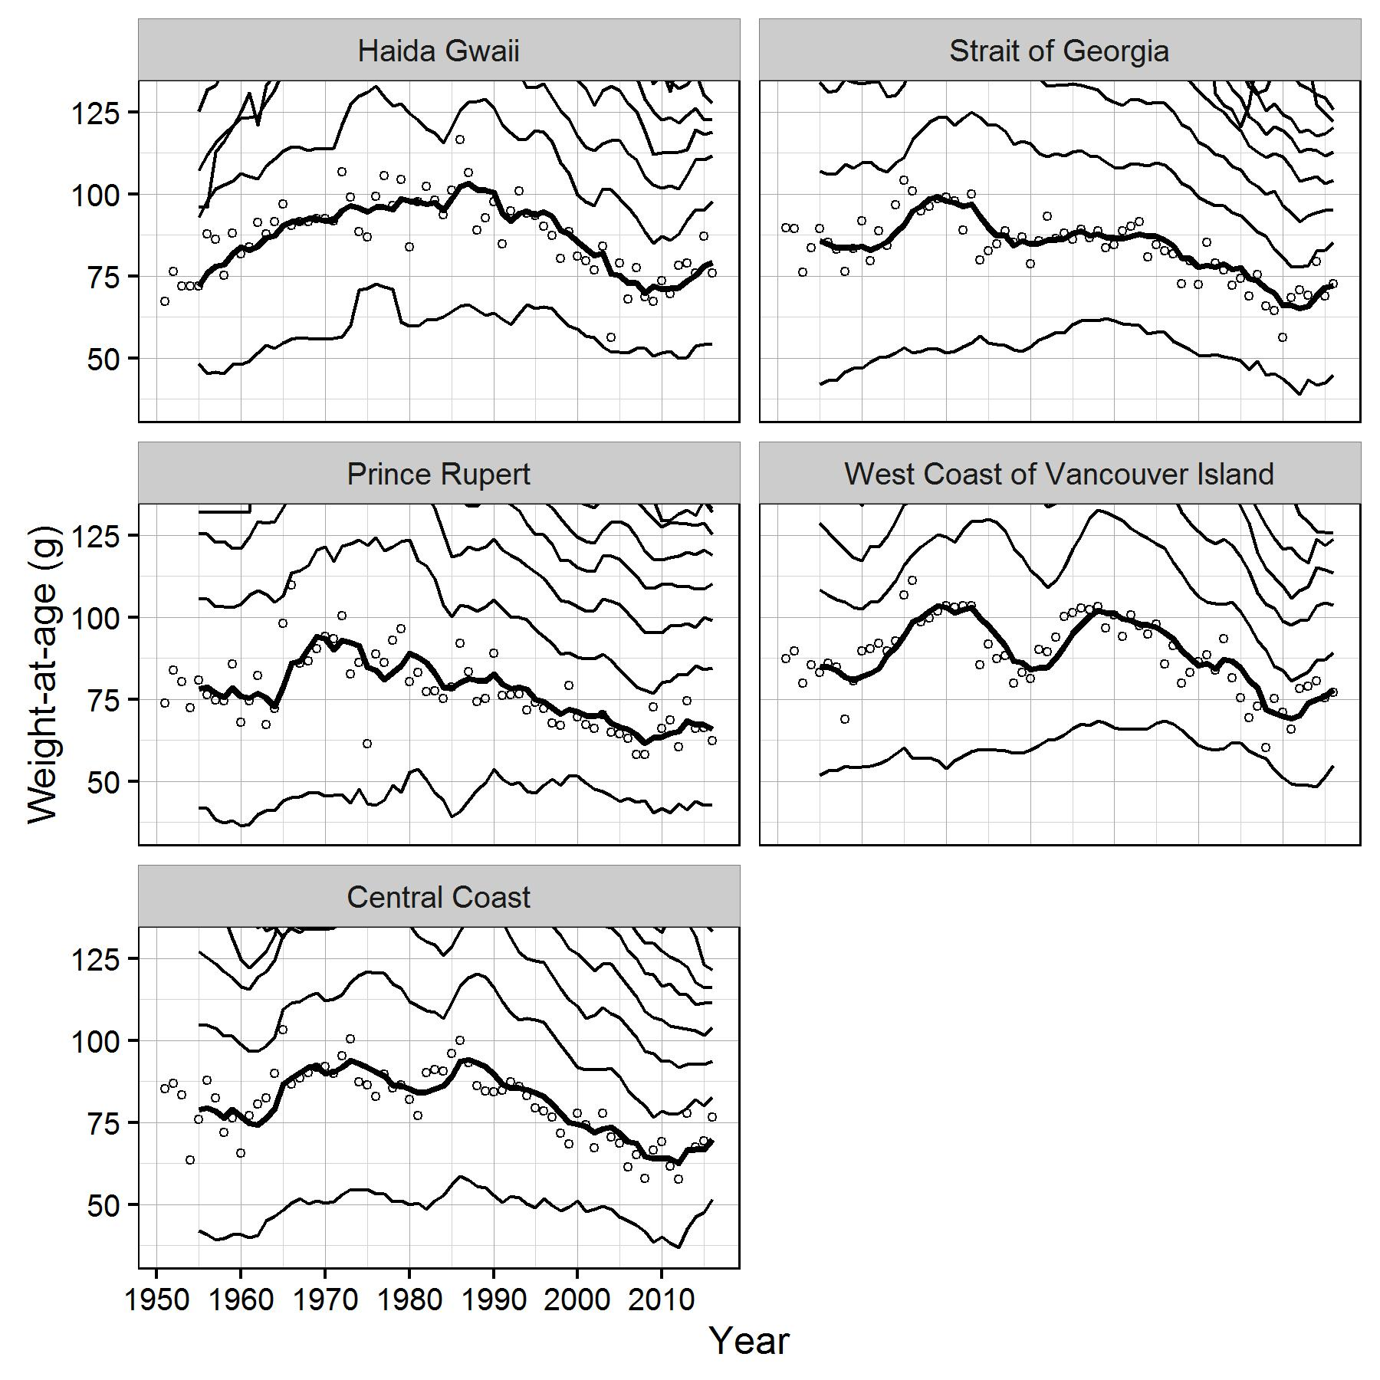  
Figure 1. Time series of observed mean weight at age of age3 fish (circles) and five-year running mean weight at age 3 (thick black lines) for the major stock areas. Thinner black lines represent five-year mean weight at age 2 (lowest) and ages 4-10 (incrementing upwards from age 3).

#### Coast-wide Trends in Catch, Spawning Biomass, and Natural Mortality

Relative to the reduction fishery period (1951-1965), catches have been much smaller. On several occasions between 1951 and 1965 coast-wide catch exceeded 150 kt, with a maximum of 220 kt in 1956 (Figure 2). Following a closure in the late 1960s, coast-wide catch in the 1970s went from 8.9 kt to a peak of 82 kt in 1976. In the 1980s, catches ranged between 16 and 41 kt and in the 1990s between 22 and 40 kt. Coast-wide catches generally declined between 2005 and 2011 from 31 kt to 7.3 kt, respectively.

Like the catches, the estimates of coast-wide spawning biomass have varied considerably since 1950 (Figure 3). Following the reduction fishery period, the estimated coast-wide biomass was lowest in the mid-1960s. The highest estimated coast-wide biomass occurred in the late 1970s. The second period of estimated lowest biomass occurred between 2000 and 2010. Important to note is that reduction fishery catches include a high proportion of immature fish, which are not reflected in the spawning biomass presented in Figure 3. While patterns of estimated coast-wide biomass are similar between AM1 and AM2, each assessment model produces very different absolute coast-wide biomass estimates (Figure 3). Both AM1 and AM2 show that, before 1990, the coast-wide herring biomass was distributed more evenly among the major stock areas (Figure 3 and 4). During earlier time periods, large proportions of the coast-wide spawning biomass are estimated to have occurred in both the WCVI, e.g., in the mid-1970s, and combined over PRD and CC in the mid-1980s (Figure 4). Since 1985, the relative contribution of the SOG to the total estimated coast-wide spawning biomass has been progressively increasing, and both assessment models estimate that greater than 50% of the coast-wide spawning biomass now occurs there (Figure 4). In general, AM2 estimates spawning biomass values that are less than the AM1 model, with median biomass estimates from 2007-2016 being on average 51%, 8%, 38%, 43% and 50% less for AM2 than AM1 in each of the major stock areas, HG, PRD, CC, SOG, and WCVI, respectively. Estimated spawning biomass (SB) from 2012-2016 (AM1 and AM2) is reported in Table 2, and SB2016 as well as estimated equilibrium unfished spawning biomass (SB0, based on long-term average weight-at-age and M rates), 0.25SB0, and the ratio SB2016/ SB0 for all BC herring stocks are reported in Table 3. Associated with both fisheries closures and apparent changes in the relative distribution of the coast-wide spawning biomass, the proportion of coast-wide catch that comes out of the SOG stock has progressively increased from 22% in 1990 to greater than 80% in 2016 (Figure 4, top).

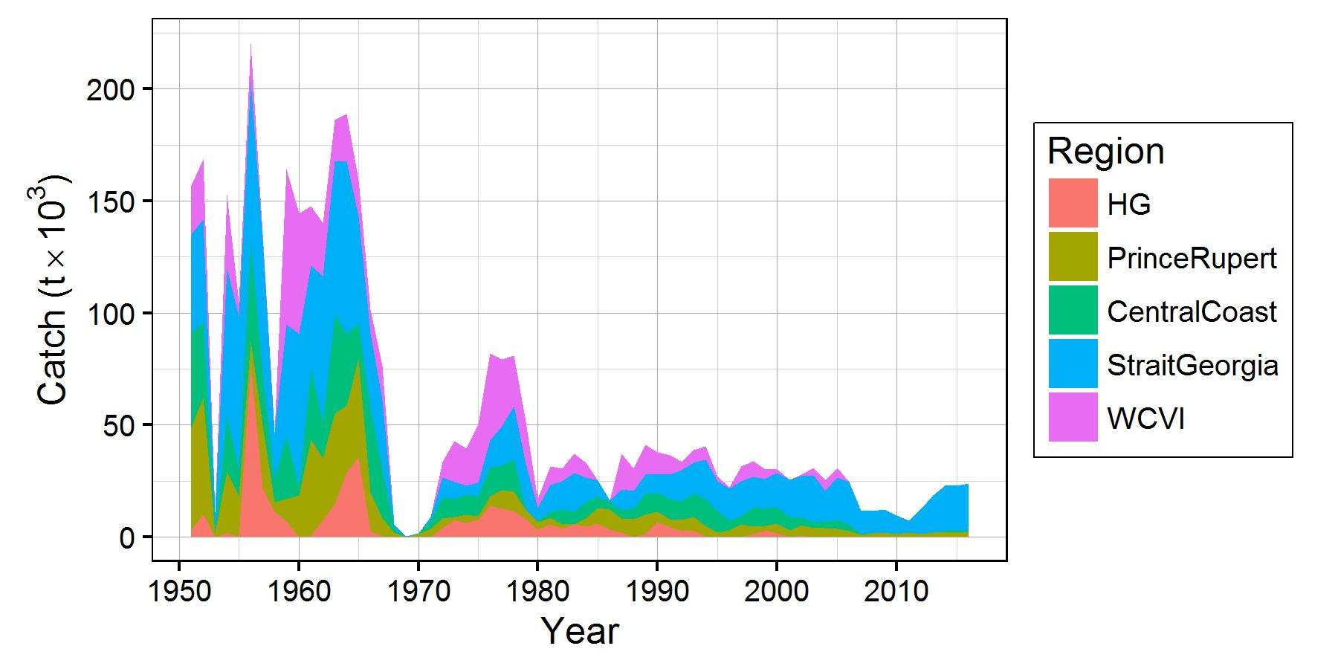Figure 2. Stacked plots of coast-wide catch by area, in kilotonnes (kt).

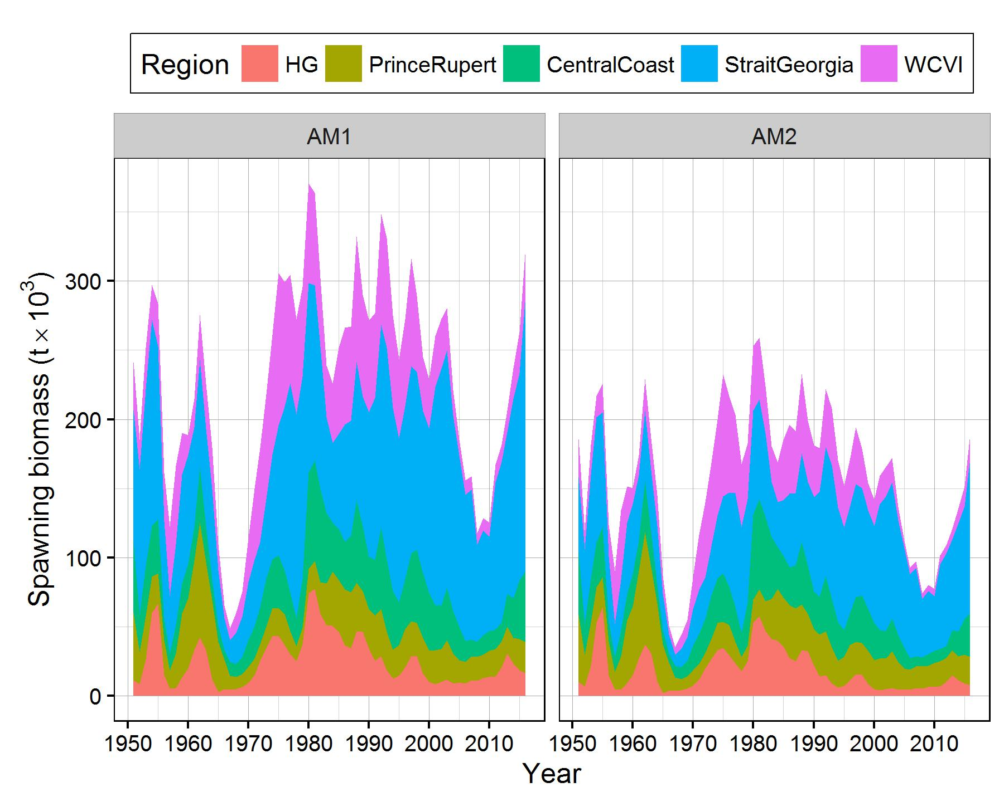

Figure 3. Stacked plots of coast-wide biomass estimates by area for AM1 (estimate q2/estimate cut-off model) and AM2 (dive survey q2 is fixed at one/ fixed cut-offs).

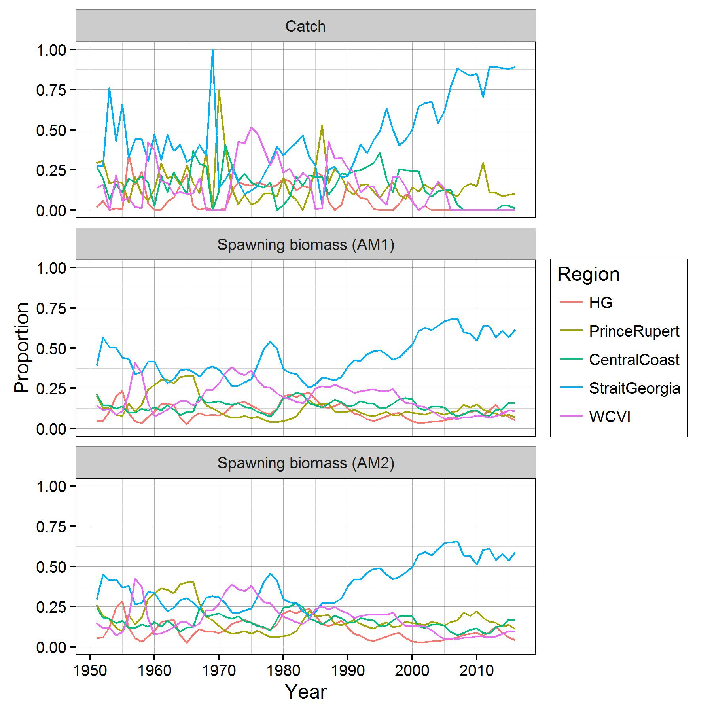

Figure 4. Proportion of total catches by area (top panel) and proportion of spawning biomass among areas estimated using AM1 and AM2 assessment models (bottom two panels).

Both AM1 and AM2 assessment models estimate changes in natural mortality (*M*) over time. While there are some differences between *M* estimates from AM1 and AM2, the trends are similar with the estimated median *M* having differed among the major stock areas in the last 15 years (Figure 5). In all areas, estimated *M* increased for several years following the pre-1970 reduction fishery period (Figure 5). Median estimated *M* is estimated to be declining in CC and SOG from 2008-2016, while estimated spawning biomass in these areas increases (see figures by stock area). In PRD, median estimated *M* oscillates along an increasing trajectory from 1980-2016 (Figure 5). For HG and WCVI, median estimated *M* increases from the lowest values in the late 1950’s/ early 1960’s to the highest values in 2002 (HG) and 2007 (WCVI). For all stocks (both AM1 and AM2 models), the uncertainty around estimated *M* is very high in recent years, as evident in the 90% credible intervals shown for individual stocks (see figures by stock area).

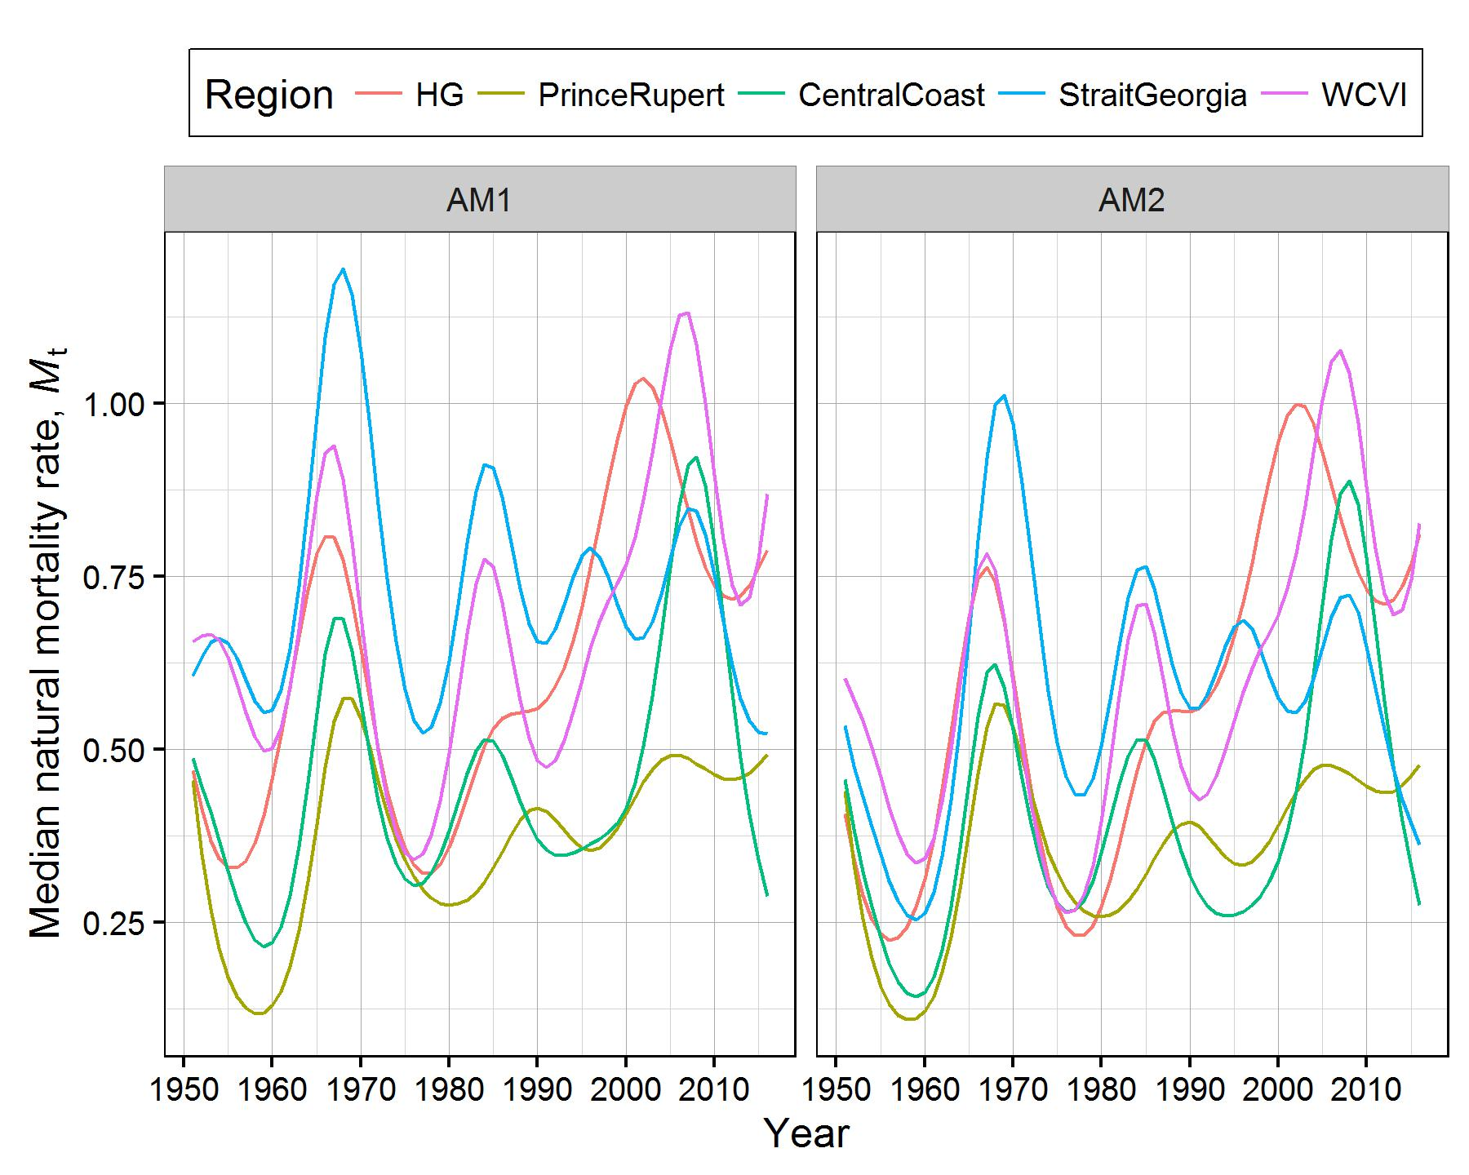  
Figure 5. Time series of median posterior estimates of natural mortality rate for the major stock areas for AM1 and AM2 assessment models.

Table 2. Median estimates (with 5-95% credible interval) of spawning biomass (SBt) for BC herring stocks, 2012-2016. SBt is units of metric tonnes.

| Stock | AM | 2012 | 2013 | 2014 | 2015 | 2016 |
| --- | --- | --- | --- | --- | --- | --- |
| HG | AM1 | 20,789 | 30,544 | 23,358 | 18,534 | 16,405 |
| (13,930 - 31,513) | (20,223 - 47,704) | (15,373 - 36,678) | (11,605 - 29,951) | (8,489 - 29,458) |
| AM2 | 10,167 | 15,007 | 11,532 | 8,978 | 7,715 |
| (7,713 - 13,432) | (11,173 - 20,333) | (8,552 - 15,615) | (6,374 - 12,746) | (4,179 - 13,582) |
| PRD | AM1 | 18,718 | 19,539 | 18,542 | 22,799 | 22,289 |
| (13,131 - 27,762) | (13,606 - 28,551) | (12,848 - 27,002) | (14,885 - 34,641) | (12,772 - 38,721) |
| AM2 | 17,227 | 17,995 | 17,163 | 21,043 | 20,747 |
| (13,972 - 21,416) | (14,628 - 22,541) | (13,645 - 21,682) | (15,628 - 28,559) | (12,440 - 34,016) |
| CC | AM1 | 13,894 | 23,736 | 28,693 | 42,320 | 51,437 |
| (9,905 - 19,707) | (16,883 - 33,890) | (20,063 - 41,118) | (28,419 - 62,280) | (31,657 - 80,856) |
| AM2 | 8,746 | 14,802 | 17,587 | 25,708 | 31,536 |
| (7,038 - 10,790) | (12,035 - 18,577) | (14,154 - 21,899) | (19,699 - 33,583) | (21,424 - 45,148) |
| CC  (06,07,08) CC (06,07) | AM1 | 13,047 | 22,084 | 26,269 | 39,584 | 49,635 |
| (9,252 - 18,509) | (15,533 - 31,452) | (18,010 - 37,703) | (25,932 - 59,602) | (29,959 - 80,726) |
| AM2 | 8,067 | 13,526 | 15,815 | 23,550 | 30,042 |
| (6,517 - 9,982) | (10,963 - 16,764) | (12,614 - 19,848) | (17,766 - 31,165) | (20,011 - 43,263) |
| SOG | AM1 | 115,905 | 116,829 | 144,023 | 149,746 | 199,604 |
| (84,506 - 160,779) | (83,051 - 164,359) | (99,495 - 204,799) | (101,634 - 221,918) | (124,805 - 331,469) |
| AM2 | 66,472 | 65,351 | 78,473 | 81,198 | 111,677 |
| (57,330 - 79,600) | (55,008 - 78,269) | (64,049 - 95,401) | (63,199 - 102,447) | (75,882 - 160,999) |
| WCVI | AM1 | 12,540 | 15,647 | 22,136 | 29,563 | 35,125 |
| (8,295 - 18,430) | (10,242 - 23,232) | (14,312 - 33,552) | (19,092 - 45,678) | (19,170 - 62,646) |
| AM2 | 6,287 | 7,749 | 10,993 | 14,743 | 17,862 |
| (4,899 - 8,067) | (5,929 - 10,015) | (8,292 - 14,422) | (10,837 - 19,776) | (10,570 - 29,158) |
| Area 2W | AM1 | 4,013 | 4,237 | 4,151 | 4,882 | 4,468 |
| (2,341 - 6,881) | (2,430 - 7,385) | (2,251 - 7,548) | (2,398 - 9,667) | (1,783 - 10,057) |
| AM2 | 1,777 | 1,874 | 1,838 | 2,165 | 2,004 |
| (1,205 - 2,492) | (1,224 - 2,743) | (1,132 - 2,901) | (1,153 - 3,830) | (828 - 4,069) |
| Area 27 | AM1 | 1,186 | 1,319 | 1,295 | 1,550 | 1,732 |
| (730 - 1,933) | (802 - 2,194) | (810 - 2,160) | (931 - 2,701) | (884 - 3,263) |
| AM2 | 1,011 (737 - 1,395) | 1,145 (790 - 1,611) | 1,123 (796 - 1,589) | 1,335 (899 - 1,987) | 1,497 (833 - 2,498) |

Table 3. Median estimates (with 5-95% credible interval) of 2016 spawning biomass (SB2016), estimated equilibrium unfished spawning biomass (SB0), 0.25SB0, and the ratio SB2016/ SB0 for all BC herring stocks. SB0 reflects long-term average weight-at-age and natural mortality rates.

|  |  | Spawning biomass (*SB*2016) | | | Unfished biomass (*SB*0) | | | 0.25\**SB*0 | | | Median ratio of spawning biomass to unfished equilibrium  spawning biomass (*SB*2016/*SB*0) | | |
| --- | --- | --- | --- | --- | --- | --- | --- | --- | --- | --- | --- | --- | --- |
| Stock | AM | 5th %ile | Median | 95th %ile | 5th %ile | Median | 95th %ile | 5th %ile | Median | 95th %ile | 5th %ile | Median | 95th %ile |
| HG | AM1 | 8,489 | 16,405 | 29,458 | 28,582 | 39,427 | 56,947 | 7,146 | 9,857 | 14,237 | 0.22 | 0.41 | 0.71 |
| AM2 | 4,179 | 7,715 | 13,582 | 19,881 | 25,451 | 34,281 | 4,970 | 6,363 | 8,570 | 0.16 | 0.30 | 0.54 |
| PRD | AM1 | 12,772 | 22,289 | 38,721 | 45,678 | 58,276 | 84,171 | 11,420 | 14,569 | 21,043 | 0.20 | 0.38 | 0.68 |
| AM2 | 12,440 | 20,747 | 34,016 | 45,321 | 57,702 | 84,705 | 11,330 | 14,425 | 21,176 | 0.20 | 0.35 | 0.59 |
| CC | AM1 | 31,657 | 51,437 | 80,856 | 47,782 | 59,599 | 75,743 | 11,946 | 14,900 | 18,936 | 0.54 | 0.86 | 1.32 |
| AM2 | 21,424 | 31,536 | 45,148 | 43,592 | 54,298 | 70,461 | 10,898 | 13,574 | 17,615 | 0.37 | 0.57 | 0.85 |
| CC  (06,07,08) CC (06,07) | AM1 | 29,959 | 49,635 | 80,726 | 44,581 | 55,504 | 71,321 | 11,145 | 13,876 | 17,830 | 0.54 | 0.89 | 1.41 |
| AM2 | 20,011 | 30,042 | 43,263 | 39,993 | 50,305 | 65,415 | 9,998 | 12,576 | 16,354 | 0.38 | 0.59 | 0.89 |
| SOG | AM1 | 124,805 | 199,604 | 331,469 | 117,993 | 145,962 | 185,855 | 29,498 | 36,491 | 46,464 | 0.91 | 1.37 | 2.12 |
| AM2 | 75,882 | 111,677 | 160,999 | 98,825 | 115,870 | 141,994 | 24,706 | 28,968 | 35,499 | 0.62 | 0.96 | 1.40 |
| WCVI | AM1 | 19,170 | 35,125 | 62,646 | 44,973 | 56,047 | 71,365 | 11,243 | 14,012 | 17,841 | 0.36 | 0.62 | 1.05 |
| AM2 | 10,570 | 17,862 | 29,158 | 36,263 | 43,839 | 55,255 | 9,066 | 10,960 | 13,814 | 0.23 | 0.41 | 0.67 |
| Area 2W | AM1 | 1,783 | 4,468 | 10,057 | 2,123 | 3,413 | 6,067 | 531 | 853 | 1,517 | 0.54 | 1.30 | 2.69 |
| AM2 | 828 | 2,004 | 4,069 | 1,390 | 2,185 | 3,924 | 348 | 546 | 981 | 0.37 | 0.88 | 1.83 |
| Area 27 | AM1 | 884 | 1,732 | 3,263 | 1,477 | 2,147 | 3,284 | 369 | 537 | 821 | 0.44 | 0.79 | 1.41 |
| AM2 | 833 | 1,497 | 2,498 | 1,388 | 1,755 | 2,339 | 347 | 439 | 585 | 0.47 | 0.84 | 1.43 |

Table 4. Estimates of projected pre-harvest spawning biomass in 2017 assuming no fishing, and predicted proportions of fish of age-3 and of ages 4-10 for all BC herring stocks. Projected proportions age-3 and ages 4-10 are near identical between AM1/ AM2, thus only one set of values are included.

|  |  | Projected pre-harvest  spawning biomass (*SB2017*) | | | Projected proportion age 3 fish in 2017 | | | Projected proportion ages 4-10 fish in 2017 | | |
| --- | --- | --- | --- | --- | --- | --- | --- | --- | --- | --- |
| Stock | MP | 5th %ile | Median | 95th %ile | 5th %ile | Median | 95th %ile | 5th %ile | Median | 95th %ile |
| HG | AM1 | 9,775 | 20,700 | 40,781 | 0.31 | 0.51 | 0.66 | 0.21 | 0.35 | 0.48 |
| AM2 | 4,930 | 9,784 | 19,620 |
| PRD | AM1 | 12,499 | 23,080 | 41,902 | 0.06 | 0.17 | 0.36 | 0.54 | 0.74 | 0.87 |
| AM2 | 12,030 | 21,790 | 38,161 |
| CC  (06,07,08) | AM1 | 27,998 | 47,855 | 78,300 | 0.21 | 0.30 | 0.39 | 0.53 | 0.64 | 0.73 |
| AM2 | 19,140 | 29,600 | 45,260 |
| *Spawn index* | - | 32,721 | - | - | - | - | - | - | - |
| CC  (06,07) | AM1 | 27,010 | 46,535 | 79,714 | 0.21 | 0.30 | 0.39 | 0.53 | 0.64 | 0.72 |
| AM2 | 18,230 | 28,690 | 44,383 |
| *Spawn index* | *-* | 30,803 | *-* | *-* | *-* | *-* | *-* | *-* | *-* |
| SOG | AM1 | 158,700 | 264,900 | 460,505 | 0.44 | 0.53 | 0.60 | 0.33 | 0.41 | 0.48 |
| AM2 | 102,800 | 158,100 | 245,510 |
| WCVI | AM1 | 17,530 | 33,580 | 63,251 | 0.20 | 0.30 | 0.40 | 0.41 | 0.54 | 0.65 |
| AM2 | 9,837 | 17,800 | 30,741 |
| Area2W | AM1 | 1,530 | 4,375 | 10,790 | 0.02 | 0.05 | 0.10 | 0.83 | 0.93 | 0.96 |
| AM2 | 698 | 1,973 | 4,466 |
| Area27 | AM1 | 884 | 1,873 | 3,805 | 0.09 | 0.22 | 0.48 | 0.43 | 0.68 | 0.85 |
| AM2 | 823 | 1,617 | 2,983 |

#### Projection Results and Decision Tables

Projected pre-harvest spawning biomass estimates (i.e., prior to any harvest in 2017), and the relative contribution of fish of age-3 and ages 4-10 are presented in Table 4. Advice to managers for 2017 for each stock area is presented in the stock-specific sections below, as two sets of decision tables, one for each assessment model (AM1 and AM2). Tables from AM1 provide probabilities of the projected post-harvest spawning biomass in 2017 (*SB*2017) falling below the currently-estimated 0.25*SB*0 level, and of the harvest rate exceeding the 20% and 10% target harvest rates over a range of constant 2017 catch levels. Tables from AM2 provide probabilities of the projected post-harvest spawning biomass in 2017 (*SB*2017) falling below the historically-used stock-specific fixed cut-off levels (calculated as 0.25*SB*0 from the 1996 (Schweigert et al. 1997), and of the harvest rate exceeding the 20% and 10% target rates over a range of constant catch levels.

Below is an example of how to read the tables for the five major stock areas (HG, PRD, CC, SOG, WCVI):

Using AM1 (Table 5, Left, Row 7), given a 2017 catch of 2,120 t from HG, the estimated probability that the harvest rate (*U*’) exceeds the 20% target rate is 0.05 (5.0%), the ratio of *SB*2017/0.25*SB*0 is 1.96, and the probability that *SB*2017 < 0.25*SB*0 is estimated to be 0.07 (7.0%). Under the assumptions of AM2 (Table 5, Right), given the same catch of 2,120 t from HG, the estimated probability that the harvest rate (*U*’) exceeds the 20% target rate is 0.50 (50%), and the probability that *SB*2017 < fixed cut-off (10,700 t) is estimated to be 0.69 (69%).

#### Haida Gwaii

*Survey data:*

In 2016, biological samples were collected by a seine test charter vessel funded by DFO. The primary purpose of the test charter vessel was to collect biological samples from main aggregations of herring from Haida Gwaii major (priority) and the Area 2W minor stock, identified from soundings. The vessel operated from March 10th to April 3rd, collecting samples from HG and Area 2W. The spawn reconnaissance vessel operated from March 30th to   
April 17th, and the dive charter vessel from March 31st to April 18th. A total of five biological samples were collected in the HG major stock area (approx. 100 fish per sample).

Haida Fisheries Program conducted the herring spawn dive surveys in Haida Gwaii from   
April 3rd to April 22nd aboard the Haida Spirit. In addition to the test charter and spawn data collections programs, there were several general observations made during the data collection operations and locally.

*First Nations observations in Haida Gwaii:*

The herring spawn in the Haida Gwaii major stock area over the past two years was unusual compared to previous years, in terms of both spawn duration and location. In 2016 the majority of the spawn in the Skincuttle and Juan Perez area occurred over a relatively short time period from March 26th to April 10th. The earliest spawn occurred in Louscoone in mid-March and the last spawning was observed on April 15th in Selwyn. Some spawn was observed in Carpenter Bay. The spawn located and surveyed covered a total of 30.3 km of substrate. Both the dive team and the local managers reported that there was not much whale, sea lion and bird activity after the spawn. Divers observed fungus covering the spawn at Poole Inlet and Harriet Harbour. In general, Haida traditional harvest of spawn on kelp in the major stock area was very small, if at all. Similar to 2015, warmer water temperatures than usual were observed throughout the area which may have contributed to the shorter spawning period.

*Biomass estimates, trends and forecasts:*

The time series of spawn survey data (survey index) for the HG major stock declined from 13,860 t in 2001 to 2,286 t in 2002, following which the index fluctuated from 3,614 t to 9,794 t (average: 6,429 t) from 2003 to 2011. Survey index remained above 10,500 t from 2012-2015 (peak in 2013), and declined from 13,102 t (2015) to 6,888 t in 2016.(Figures 6a and 7a, Table A.1). The model fits the spawn survey data with survey residuals of less than 0.5 for the duration of 2002-2016 (figure not shown). Both models estimate low relative biomass from 2000-2011, with increasing biomass in 2012 and 2013, followed by declines in 2014-2016 (Figures 6d and 7d, Table 2).

AM1 estimates the median spawning biomass in 2016 (*SB*2016) at 16,405 t and *SB*2016 is estimated to be 41% (median) of the unfished level, *SB*0 (Table 2 and 3). AM2 estimates the median spawning biomass in 2016 (*SB*2016) at 7,715 t and 30% of *SB*0. The pattern of biomass estimates for AM2 is similar to that of AM1, however AM2 estimates of spawning biomass in 2016 (*SB*2016) and stock status relative to *SB*0 are lower than the AM1 estimates (Tables 2 and 3). Higher estimates of spawning biomass and higher estimates of stock status relative to *SB*0 for AM1 result largely from scaling of the biomass through estimation of *q*. AM1 median estimates of *q*1 and *q*2 are 0.32 and 0.52, respectively. AM2 median estimates of *q*1 and *q*2 are 0.39 and 1.0 (Table A.3). AM1 estimates of *q*2 approximate the *q*2 prior of ~0.5.

Both AM1 and AM2 project an increase in median spawning biomass from 2016 to 2017, following the declining estimates from 2013-2016. In the absence of fishing, AM1 and AM2 project the median spawning biomass in 2017 at 20,700 t and 9,784 t, respectively, consisting of 51% (median) age-3 fish and 35% (median) age-4 and older fish (Table 4). Projected proportions of age-3 and age-4 and older fish are near-identical from both models. Contributing to the projected increase in spawning biomass in 2017, using both stock assessment models, is above average recruitment of age-2 fish in 2016 and the strength of the 2010 year class (appearing as above average recruitment of age-2 fish in 2012 (Figures 6b and 7b). There is a high degree of uncertainty in the 2016 estimates of age-2 recruits, due in part to low sample size (5 samples, n~ 500 fish). In the absence of fishing, AM1 estimates that there is a 5% probability the stock will be below the cut-off of 0.25*SB*0 in 2017 and AM2 estimates a 59% probability of being below the fixed cut-off level of 10,700 t in 2017 (Table 5).

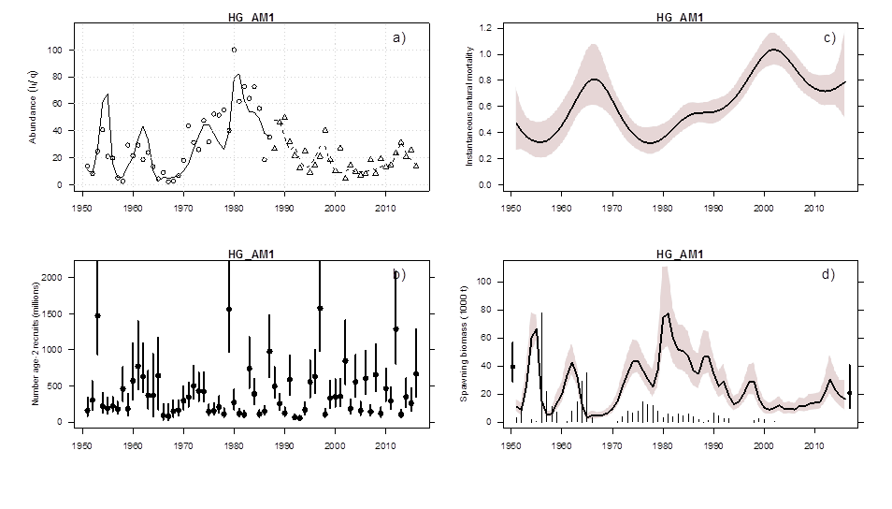

Figure 6. Model outputs for Haida Gwaii, AM1. Upper left panel (a) shows model fit to time series of spawn survey data. Open circles and open triangles reflect time series of surface (1951-1987) and dive (1988-2016) survey data. Index values are reported in Appendix, Table A-2.; Lower left panel (b) shows the reconstruction of number of age-2 recruits (millions). Solid circles with vertical lines represent medians and 5-95% credible intervals, respectively; Upper right panel (c) shows posterior estimates of instantaneous natural mortality; Lower right panel (d) shows the posterior estimates of spawning biomass (SBt) for each year t, with unfished values (SB0) shown at far left (solid circle and vertical lines) and the projected spawning biomass assuming no fishing (SB2017) using AM1 shown at the far right (solid circle and vertical lines). Time series of thin vertical lines denote commercial catch (excluding commercial SOK). Solid lines with surrounding pink envelopes represent medians and 5-95% credible intervals, respectively. Model outputs from AM2/ AM2 show similar trends with lower numeric values for HG, CC, SOG and WCVI (Tables 2-4).

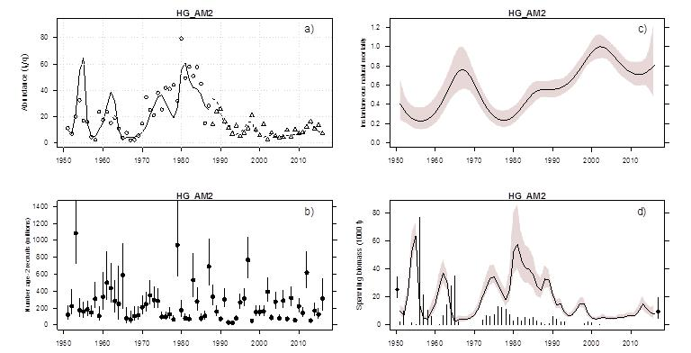

Figure 7. Model outputs for Haida Gwaii, AM2. See detailed description in Figure 6.

*Table 5. Decision tables concerning the harvest and biomass metrics drawn from* ***AM1*** *(left) and* ***AM2*** *(right) for projected spawning biomass in 2017, given a range of total allowable catch (TAC) (in tonnes) for* ***Haida Gwaii****. Probabilities are estimated using the proportion of the MCMC samples that meet the given criteria. One-year projections for HG use catch allocation ratios for each of the three fisheries (F&B/ SU, seine roe and gillnet roe) based on 20-year historical average catches.*

*Left (****AM1****): Values are probabilities, under each TAC level, of the post-harvest spawning biomass in 2017 (SB2017) falling below 0.25SB0, and of the harvest rate (HR) being greater than 20% or 10%.*

| **Haida Gwaii (HG)** | | | | | |
| --- | --- | --- | --- | --- | --- |
|  | **Biomass metrics – AM1** | | **Harvest metrics – AM1** | | |
| TAC | Prob **(**biomass after harvest is below 0.25*SB*0 in 2017) | Median ratio of projected post-harvest biomass to 0.25*SB*0 | Prob (removal rate > target HR) | Prob (removal rate > target HR) | Median removal rate |
| (metric tonnes) | P(*SB*2017 < 0.25*SB*0) | Med (*SB*2017 / 0.25*SB*0) | P(U’2017 > 20%) | P(U’2017 > 10%) | Med (U’2017) |
| 0 | 0.05 | 2.09 | 0.00 | 0.00 | 0.00 |
| 500 | 0.05 | 2.06 | 0.00 | 0.00 | 0.02 |
| 750 | 0.06 | 2.04 | 0.00 | 0.01 | 0.04 |
| 1,000 | 0.06 | 2.02 | 0.00 | 0.04 | 0.05 |
| 1,020 | 0.06 | 2.02 | 0.00 | 0.05 | 0.05 |
| 2,000 | 0.07 | 1.96 | 0.04 | 0.43 | 0.09 |
| 2,120 | 0.07 | 1.96 | 0.05 | 0.48 | 0.10 |
| 2,160 | 0.07 | 1.95 | 0.05 | 0.50 | 0.10 |
| 3,000 | 0.08 | 1.90 | 0.19 | 0.79 | 0.14 |
| 3,500 | 0.09 | 1.87 | 0.29 | 0.89 | 0.16 |
| 4,000 | 0.10 | 1.84 | 0.39 | 0.94 | 0.18 |
| 4,500 | 0.11 | 1.82 | 0.50 | 0.96 | 0.20 |
| 5,000 | 0.12 | 1.79 | 0.60 | 0.98 | 0.22 |
| 5,500 | 0.14 | 1.75 | 0.68 | 0.98 | 0.24 |
| 6,000 | 0.15 | 1.72 | 0.76 | 0.99 | 0.26 |

*Right (****AM2****): Values are probabilities, under each TAC level, of the post-harvest spawning biomass in 2016 (SB2017) falling below fixed cut-off of 10,700 t, and of the harvest rate (HR) being greater than 20% or 10%.*

| **Haida Gwaii (HG)** | | | | | |
| --- | --- | --- | --- | --- | --- |
|  | **Biomass metrics – AM2** | | **Harvest metrics – AM2** | | |
| TAC | Prob (biomass after harvest is below cut-off in 2017 | Median ratio of projected post-harvest biomass to cut-off | Prob (removal rate > target HR) | Prob (removal rate > target HR) | Median removal rate |
| (metric tonnes) | P(*SB*2017 < 10,700 t) | Med (*SB*2017 / 10,700 t) | P(U’2017 > 20%) | P(U’2017 > 10%) | Med (U’2017) |
| 0 | 0.59 | 0.91 | 0.00 | 0.00 | 0.00 |
| 500 | 0.62 | 0.89 | 0.00 | 0.04 | 0.05 |
| 750 | 0.63 | 0.87 | 0.01 | 0.23 | 0.07 |
| 1,000 | 0.65 | 0.86 | 0.04 | 0.48 | 0.10 |
| 1,020 | 0.65 | 0.86 | 0.04 | 0.50 | 0.10 |
| 2,000 | 0.69 | 0.80 | 0.44 | 0.95 | 0.19 |
| 2,120 | 0.69 | 0.80 | 0.50 | 0.96 | 0.20 |
| 2,160 | 0.70 | 0.79 | 0.52 | 0.96 | 0.20 |
| 3,000 | 0.73 | 0.75 | 0.80 | 0.99 | 0.27 |
| 3,500 | 0.74 | 0.72 | 0.89 | 1.00 | 0.31 |
| 4,000 | 0.76 | 0.70 | 0.93 | 1.00 | 0.35 |
| 4,500 | 0.77 | 0.67 | 0.96 | 1.00 | 0.39 |
| 5,000 | 0.79 | 0.64 | 0.98 | 1.00 | 0.42 |
| 5,500 | 0.80 | 0.62 | 0.99 | 1.00 | 0.45 |
| 6,000 | 0.82 | 0.59 | 0.99 | 1.00 | 0.49 |

#### Prince Rupert District

Because there were multiple commercial fisheries in the PRD (2,425 t, excluding SOK), there are more biological samples relative to the adjacent areas. There were a total of 44 samples processed for PRD; 11 test samples and 33 commercial fishery samples. Test charter vessels collected samples in both Big Bay and Kitkatla, through the latter two weeks of March. Similar to patterns seen on the rest of the coast, the mean weight at age observed in the PRD samples has been stable since 2010, following a period of decline from ~1980-2010 (Figure 1).

A 20-day dive survey measured a total of 48.5 linear kilometres of spawn from late-March through mid-April. There was a modest increase in the dive survey index in 2016, to 18,985 t, up from 17,407 t in 2015 (Table A.2). The increase in spawn index is driven by an increase in spawn width and in number of egg layers. Total spawn length declined from 2015.

Since the mid-1990s, the PRD stock is characterized by two periods of consistent, stable biomass: 1996-2003 and 2006-2016 (Figures 8d and 9d). These stable trends in the biomass estimates are consistent with trends in dive survey observations (Figures 8a and 9a, Table A.2). Both AM1 and AM2 estimate a large recruitment of age 2 fish to the population in 2014 and 2015, relative to the last 10-years (Figures 8b and 9b), owing largely to the age composition information showing a high proportion of samples consisting of this age class. The median AM1 estimate of the 2016 spawning biomass is 22,289 t, relative to 22,799 t in 2015 (Table 2). AM2 shows a similar pattern, with estimates of 20,747 t in 2016 and 21,043 t in 2015. Stock status in 2016 is estimated at 38% (AM1) and 35% (AM2) of the unfished level (Table 3). Both AM1 and AM2 predict a continued stable trend in spawning biomass, with forecast biomass in 2017 similar to 2016 levels (Table 4). Similarities in biomass estimates from both models is due to AM1 estimating *q*2 at 0.93 (Table A.2). For PRD (AM1), there is information in the data to support a *q*2 value that differs from the prior of ~0.5.

The probabilities of being below cut-off, and of achieving selected harvest rates for a range of catch levels for the PRD major stock area for both AM1 and AM2 are reported in Table 6. When comparing predictions from AM1 and AM2, unlike the other stock areas, AM1 predicts a higher probability of being below the 0.25*SB*0 level (when estimating *q*2), and AM2 predicts a lower probability of being below the fixed cut-off of 12,100 t (with *q*2=1) for the same proposed catch. This is due in part to the estimate of 0.25*SB*0 (median AM1= 14,569 t; median AM2= 14,425 t) being numerically greater than the fixed cut-off level of 12,100 t for PRD. In the absence of fishing, the median projected spawning biomass level in 2017 is 23,080 t (AM1) and 21,790 t (AM2). AM1 predicts a 14% probability the PRD stock will be below the 0.25*SB*0 level, and AM2 predicts a 5% probability of being below the fixed cut-off level of 12,100 t.

Figure 8   
Figure 8. Model outputs for Prince Rupert District, AM1. See detailed description in Figure 6.

Figure 9

Figure 9. Model outputs for Prince Rupert District, AM2. See detailed description in Figure 6.

*Table 6. Decision tables concerning the harvest and biomass metrics drawn from* ***AM1*** *(left) and* ***AM2*** *(right) for projected spawning biomass in 2017, given a range of total allowable catch (TAC) (in tonnes) for* ***Prince Rupert District****. Probabilities are estimated using the proportion of the MCMC samples for which the given criteria hold. One-year projections for PRD use catch allocation ratios for each of the three fisheries (F&B/ SU, seine roe and gillnet roe) based on 20-year historical average catches*.

Left (**AM1**): Values are probabilities, under each TAC level, of the post-harvest spawning biomass in 2017 (SB2017) falling below 0.25SB0, and of the harvest rate (HR) being greater than 20% or 10%.

| **Prince Rupert District (PRD)** | | | | | |
| --- | --- | --- | --- | --- | --- |
|  | **Biomass metrics – AM1** | | **Harvest metrics – AM1** | | |
| TAC | Prob **(**biomass after harvest is below 0.25*SB*0 in 2017) | Median ratio of projected post-harvest biomass to 0.25*SB*0 | Prob (removal rate > target HR) | Prob (removal rate > target HR) | Median removal rate |
| (metric tonnes) | P(*SB*2017 < 0.25*SB*0) | Med (*SB*2017 / 0.25*SB*0) | P(U’2017 > 20%) | P(U’2017 > 10%) | Med (U’2017) |
| 0 | 0.14 | 1.58 | 0.00 | 0.00 | 0.00 |
| 2,000 | 0.19 | 1.47 | 0.01 | 0.33 | 0.08 |
| 2,230 | 0.20 | 1.46 | 0.02 | 0.44 | 0.09 |
| 2,360 | 0.20 | 1.45 | 0.03 | 0.50 | 0.10 |
| 3,000 | 0.22 | 1.42 | 0.10 | 0.74 | 0.13 |
| 4,000 | 0.26 | 1.37 | 0.30 | 0.92 | 0.17 |
| 4,575 | 0.27 | 1.34 | 0.44 | 0.97 | 0.19 |
| 4,850 | 0.28 | 1.32 | 0.50 | 0.98 | 0.20 |
| 5,000 | 0.29 | 1.32 | 0.53 | 0.98 | 0.21 |
| 5,500 | 0.31 | 1.29 | 0.63 | 0.99 | 0.23 |
| 6,000 | 0.32 | 1.27 | 0.71 | 1.00 | 0.24 |
| 6,500 | 0.34 | 1.24 | 0.79 | 1.00 | 0.26 |
| 7,000 | 0.36 | 1.22 | 0.84 | 1.00 | 0.28 |
| 7,500 | 0.37 | 1.19 | 0.88 | 1.00 | 0.30 |
| 8,000 | 0.39 | 1.16 | 0.91 | 1.00 | 0.32 |

Right (**AM2**): Values are probabilities, under each TAC level, of the post-harvest spawning biomass in 2017 (SB2017) falling below fixed cut-off of 12,100 t, and of the harvest rate (HR) being greater than 20% or 10%.

| **Prince Rupert District (PRD)** | | | | | |
| --- | --- | --- | --- | --- | --- |
|  | **Biomass metrics – AM2** | | **Harvest metrics – AM2** | | |
| TAC | Prob (biomass after harvest is below cut-off in 2017 | Median ratio of projected post-harvest biomass to cut-off | Prob (removal rate > target HR) | Prob (removal rate > target HR) | Median removal rate |
| (metric tonnes) | P(*SB*2017 < 12,100 t) | Med (*SB*2017 / 12,100 t) | P(U’2017> 20%) | P(U’2017 > 10%) | Med (U’2017) |
| 0 | 0.05 | 1.80 | 0.00 | 0.00 | 0.00 |
| 2,000 | 0.10 | 1.67 | 0.01 | 0.37 | 0.09 |
| 2,230 | 0.10 | 1.66 | 0.02 | 0.50 | 0.10 |
| 2,360 | 0.10 | 1.65 | 0.03 | 0.57 | 0.11 |
| 3,000 | 0.12 | 1.61 | 0.11 | 0.81 | 0.13 |
| 4,000 | 0.15 | 1.55 | 0.35 | 0.96 | 0.18 |
| 4,575 | 0.17 | 1.51 | 0.50 | 0.98 | 0.20 |
| 4,800 | 0.17 | 1.50 | 0.56 | 0.99 | 0.21 |
| 5,000 | 0.18 | 1.48 | 0.61 | 0.99 | 0.22 |
| 5,500 | 0.20 | 1.45 | 0.72 | 1.00 | 0.24 |
| 6,000 | 0.21 | 1.42 | 0.80 | 1.00 | 0.26 |
| 6,500 | 0.23 | 1.39 | 0.86 | 1.00 | 0.28 |
| 7,000 | 0.25 | 1.36 | 0.90 | 1.00 | 0.30 |
| 7,500 | 0.27 | 1.33 | 0.93 | 1.00 | 0.32 |
| 8,000 | 0.29 | 1.30 | 0.95 | 1.00 | 0.34 |

#### Central Coast

The Central Coast (CC) stock assessment region was historically delineated based on the combination of the distribution of spawning areas, and results of tagging studies and genetic analyses.  Areas 06, 07, and 08 were grouped together into a management area following the reduction fishery period, because a significant portion of CC catch originated from each of these areas during that time. However, Area 08 has typically had fish that were smaller at age and, although a small SOK fishery currently occurs in this area, Area 08 has been of limited interest to the commercial roe or special use sectors over the past several decades. The CC has been open for commercial fishing for 30 of the 36 years from 1980-2016. During that period, commercial fishing (non-SOK) occurred in Area 08 in three years, with annual catches all less than 100 tonnes.

Area 08 has historically made up around 10% of Central Coast assessed biomass, with 91% of spawn on average occurring in Areas 06 and 07 (average from 1980-2015). The inclusion of Area 08 in the Central Coast assessment area was identified by the Heiltsuk Tribal Council (HTC)-DFO Technical Team as an area of concern for First Nations. Specifically, concern was raised as to whether the process of including spawn from Area 08 in the aggregate CC spawning biomass has resulted in Areas 06 and 07 being fished more heavily than would be expected based on their relative contribution to the aggregate CC spawning biomass. A full study on stock structure, including review/re-evaluation of historical tagging and genetics data, and life history differences in the Central Coast assessment area is beyond the scope of this document. However, as a starting point the degree to which the available size at age data support the continued inclusion of Area 08 in the Central Coast assessment is investigated. Size data (fish weight) from Area 08 are consistently smaller on average than fish of the same age found in Areas 06 or 07. While this distinction in weight at age was clearly apparent for 1997 – 2006, it has become more pronounced in the recent decade (Figure 10). The hypothesis that the fish in Area 08 are part of a single, well-mixed ‘Central Coast’ stock predicts that weight at age distributions within all three statistical areas should be similar. The weight at age data provides evidence to suggest that the stocks in Area 08 may be distinct from those in Area 06 and 07, an observation that merits further investigation. In light of this information and past patterns of removals occurring in Areas 06 and 07 only, and because these analyses were specifically requested, estimates of spawning biomass and pre-harvest projections, and decision tables for 2017 for Central Coast herring appear under two scenarios: inclusion and exclusion of Area 08 data. These appear as CC (06,07,08) and CC (06,07) in Tables 2-4 and 7-10.

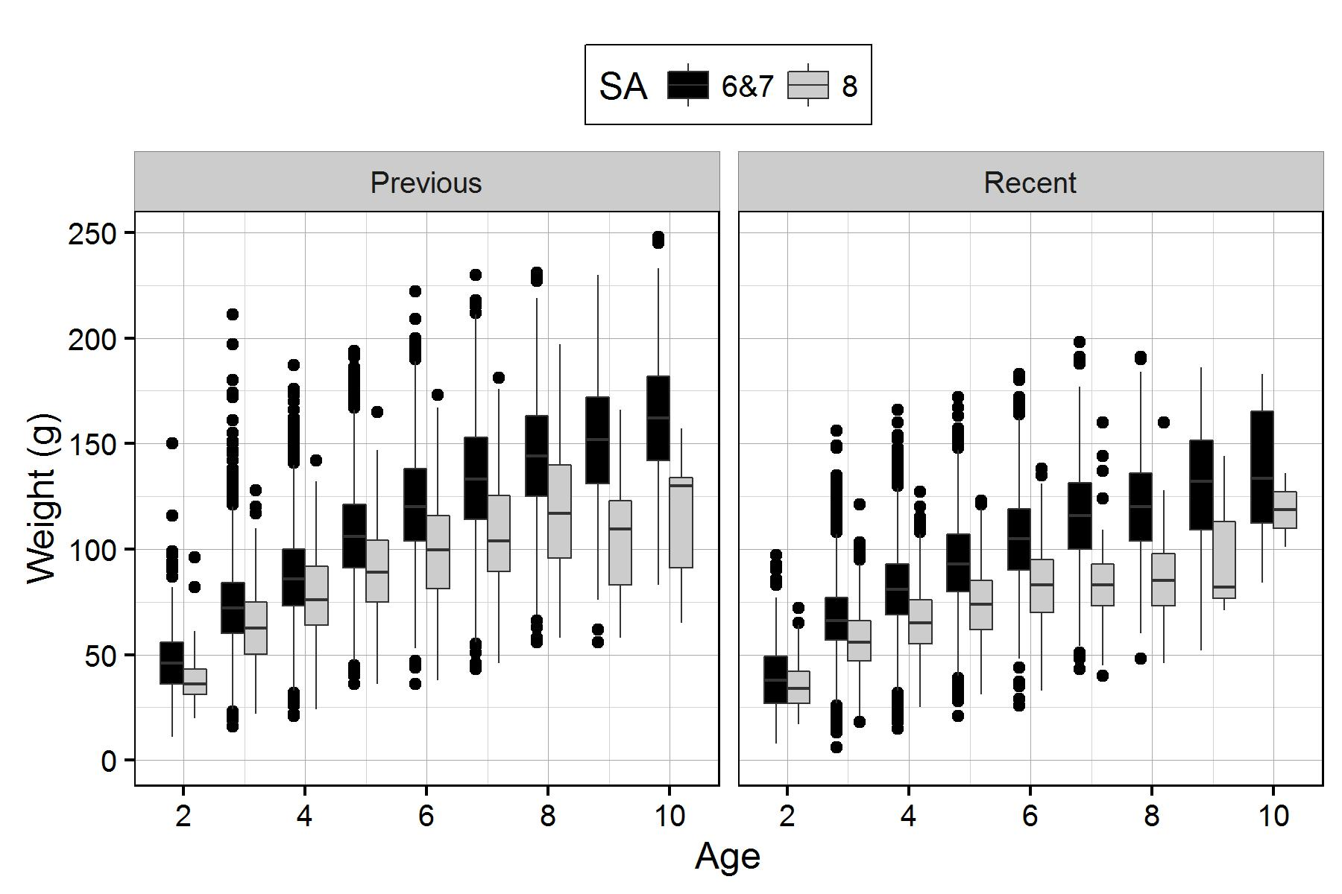  
Figure 10. Distribution of weight at age for Central Coast herring by area from the recent decade (Recent: 2007-2016), and the previous decade (Previous: 1997-2006) for biological samples from the seine roe and seine test fisheries. The outer edges of the boxes indicate the 25th and 75th percentiles, and the middle lines indicate the 50th percentiles (i.e., medians). The whiskers extend to 1.5 x IQR, where IQR is the distance between the 25th and 75th percentiles, and dots indicate outliers.

*Survey data:*

In 2016, the Heiltsuk operated three gillnet sounding vessels, two primarily in Area 07 and one primarily in Area 08 to assist in the location of fish for spawn on kelp operations. The FV *Franciscan No.1* conducted soundings and collected biological samples for 10 days in early March. Following which, the FV *Proud Canadian* was used as an in-season sounding/ biological sampling vessel for 21 days, identifying areas of high and low herring biomass, and collecting biological samples in Areas 06, 07 and 08 from pre-spawning aggregations. The Heiltsuk herring stock assessment projects have been funded by DFO though Aboriginal Fisheries Strategy (AFS) agreements.

In 2014 and 2015, the FV *Kwiaahwah* collected biological samples for the DFO stock assessment program, and to support new research initiatives occurring at SFU and UBC. Area 08 is a small section of the CC stock area and in 2014 and 2015, a high number of samples were collected in Area 08. In order to ensure consistency in the calculation of average weight at age and numbers at age for the CC stock across years, the Area 08 samples from 2015 and 2015 were weighted by the average proportion of samples from this area over the previous 20-years. In total, 15 biological samples were collected through the biological sampling program, and an additional five samples were collected from commercial fisheries.

*First Nations observations in the Central Coast:*

Some of the unusual spawning patterns observed in recent years were again seen in 2016. Heiltsuk fishers reported struggling with spot spawns and spawning locations being less predictable than in the past, as well as spawns that were deep and therefore difficult to spot. As a result, harvest on branches was poor, though the SOK fishery did achieve its TAC and was able to make up for some of the shortfall in the food fishery.

Heiltsuk fishers noted that herring roe in the Foote islands and Tankeeah area appeared not to be fertilized and after two weeks was found to be rotting on both the kelp and the SOK lines left in the water there.

Spawn survey divers noted fungus issues similar to those observed in 2015 on spawn at Clifford Bay.

There was some concern regarding catch versus spawn in the East Higgins area. There appeared to be limited spawn in the area, lower than what was expected based on pre-fishery soundings of 2,000 – 2,500 tons, where test sets identified larger mature fish. Spawn in this area was expected in excess of 1,000 – 1,500 tons, however spawn did not materialize.

An SFU-CCIRA team studying spawning depth in Kitasu Bay, Higgins Pass and Spiller Channel (via dive and tow video surveys) made the following observations:

* Deep spawn was found only at three locations in Spiller Channel.
* In all three locations, spawn covered vertical bedrock walls from the intertidal zone to depths greater than 30 meters.
* Egg survival at these deep spawn sites appeared to be exceptionally low; it is likely that most of these eggs were not fertilized.
* Deep herring spawn was substrate dependent; only occurring where deep bedrock substrate extended unbroken from the surface.
* Temperature and salinity differences between Spiller Channel and Kitasu Bay were small, and unlikely to have affected spawn depth.
* Coastal areas with high predator abundance and high vessel traffic did not overlap with areas of deep spawn.
* Opalescent squid egg masses were observed in large numbers in sections of Kitasu Bay.

Formal analyses of these and other observations are ongoing.

*Biomass estimates, trends, and forecasts:*

Two dive survey charters operated in the CC stock area, surveying a total of 164.6 linear kilometres of herring spawn between March 30 and April 22. The time series of spawn survey data for the CC aggregate stock (Area 06,07,08) includes a period of low relative survey biomass from 2006-2012. Survey values increase from 7,592 t in 2012 to 20,369 t in 2013, declined to 13,309 t in 2014, and increased to 32,146 t in 2015. The 2016 survey index value is 32,508 t (Figures 11a and 12a, Table A.2).

Recent estimates of spawning biomass track the increase in spawn index data observed since 2012 (Figures 11d and 12d, Table 2). These observations are consistent across scenarios of including/ excluding Area 08 data. Under the scenario of aggregating all CC data, the median estimates of spawning biomass in 2016 (*SB*2016) for AM1 and AM2 are 51,437 t and 31,536 t, and *SB*2016 is estimated to be 86% and 57% of the unfished level, *SB*0 (Table 2 and 3). Under the scenario of excluding the Area 08 data from the CC assessment, the median estimates of spawning biomass in 2016 (*SB*2016) for AM1 and AM2 49,635 t and 30,042 t and *SB*2016 is estimated to be 89% and 59% of *SB*0 (Table 2 and 3). The pattern of biomass estimates for AM2 is similar to that of AM1, however AM2 estimates of spawning biomass in 2016 (*SB*2016) and stock status relative to *SB*0 are lower than the AM1 estimates (Tables 2 and 3). Higher estimates of spawning biomass and stock status relative to *SB*0 for AM1 result largely from scaling of the biomass through estimation of *q*. AM1 median estimates of *q*1 and *q*2 are 0.30 and 0.64, respectively. AM2 median estimates of *q*1 and *q*2 are 0.34 and 1.0 (Table A.3).

Spawning biomass is projected to decline from 2016 to 2017. This holds for both AM1 and AM2, and is true irrespective of whether Area 08 is included or excluded from the assessment area. In the absence of fishing and under the scenario of aggregating all CC data, AM1 projects the median spawning biomass in 2017 at 47,855 t, consisting of 30% (median) age-3 fish and 64% (median) age-4 and older fish (Table 4). AM2 projects the median pre-harvest spawning biomass as 29,600 t (Table 4). Projected proportions of age-3 and age-4 and older fish are near-identical using AM2. In the absence of fishing and under the scenario of excluding the Area 08 data from the CC assessment, AM1 projects the median spawning biomass in 2017 at 46,535 t, consisting of 30% (median) age-3 fish and 64% (median) age-4 and older fish (Table 4). AM2 projects the median pre-harvest spawning biomass at 28,690 t (Table 4). Projected proportions of age-3 and age-4 and older fish are near-identical using AM1 and AM2, under both scenarios of including and excluding Area 08.

To calculate the fixed cut-off for the excluded Area 08 data scenario, the area-specific proportions of spawning observed by the dive survey since 1980 was examined. An average of 91% of herring spawn was observed in Area 06 and 07 since 1980, thus the fixed cut-off by this proportion was adjusted. Accordingly, for AM2, a fixed cut-off of 16,016 t, reflecting 91% of the CC fixed cut-off level used from 1996-2011 was used. In the absence of fishing, AM1 estimates that there is a 0% probability the stock will be below the cut-off of 25% *SB*0 in 2017 (under both data scenarios, Tables 7 and 8). AM2 estimates a 3% and 2% probability of being below fixed cut-off levels of 17,600 t and 16,016 t in 2017 (include and exclude Area 08, respectively, Tables 7 and 8).

Decision tables for CC herring include an alternate cut-off of 0.60*SB*0 and harvest rates of 5%, 10% and 20%, as was requested through the HTC-DFO Technical Team. This alternate cut-off reflects Heiltsuk concerns about continuing poor FSC harvests, as well as continuing absence of spawners from many of the traditional spawning areas of importance to the Heiltsuk. An extended period of relatively high abundance may be required to prompt re-colonization of these areas. Also, following from the May 2015 CSAS meeting, there was a request to use an empirical biomass forecasting methodology, calculated as:

forecast biomass (*SB*2017)= spawn index (*I*2016) + catch (*C*2016)

Using this method, the pre-harvest spawning biomass for 2017 is estimated as 32,721 t (Area 06,07,08) or 31,803 t (Area 06,07 only; Table 4). A 10% harvest rate was also requested, and application of this harvest rate would prescribe a TAC of 3,272 t and 3,180 t (include and exclude Area 08, respectively). The long-term performance of this alternate forecasting method and harvest decision rule is explored in Part 2 of the 2015 SR (DFO 2015b).

Figure 11

Figure 11. Model outputs for the Central Coast aggregate stock (Areas 06,07,08), AM1. See detailed description in Figure 6. Model outputs from Central Coast (Area 06,07 only) produce similar results to the aggregate stock (under both AM1 and AM2). Figures not included.

Figure 12  
Figure 12. Model outputs for the Central Coast aggregate stock (Areas 06,07,08), AM2. See detailed description in Figure 6. Model outputs from Central Coast (Area 06,07 only) produce similar results to the aggregate stock (under both AM1 and AM2). Figures not included.

Table 7. Decision tables concerning the harvest and biomass metrics drawn from **AM1** (top) and **AM2** (bottom) for projected spawning biomass in 2017, given a range of total allowable catch (TAC) (in tonnes) for **Central Coast (aggregate stock- Area 06,07,08)**. Probabilities are estimated using the proportion of the MCMC samples for which the given criteria hold. One-year projections for CC use catch allocation ratios for each of the three fisheries (F&B/ SU, seine roe and gillnet roe) based on 20-year historical average catches. **Top** (**AM1**): Values are probabilities, under each TAC level, of the post-harvest spawning biomass in 2017 (SB2017) falling below 0.25SB0, and of the harvest rate (HR) being greater than 20% or 10%. **Bottom** (**AM2**): Values are probabilities, under each TAC level, of the post-harvest spawning biomass in 20167 (SB2017) falling below fixed cut-off of 17,600 t, and of the harvest rate (HR) being greater than 20% or 10%.

| **Central Coast (CC-Area 06,07,08)** | | | | | | | | |
| --- | --- | --- | --- | --- | --- | --- | --- | --- |
| **Biomass metrics - AM1** | | | | | **Harvest metrics - AM1** | | | |
| TAC | Prob (biomass after harvest is below 0.25*SB*0 in 2017) | Median ratio of projected post-harvest biomass to 0.25*SB*0 | Prob (biomass after harvest is below 0.60*SB*0 in 2017) | Median ratio of projected post-harvest biomass to 0.60*SB*0 | Prob (removal rate > target HR) | Prob (removal rate > target HR) | Prob (removal rate > target HR) | Median removal rate |
| (metric tonnes) | P(*SB*2017 < 0.25*SB*0) | Med (*SB*2017 / 0.25*SB*0) | P(*SB*2017 < 0.60*SB*0) | Med (*SB*2017 / 0.60*SB*0) | P(U’2017 > 20%) | P(U’2017 > 10%) | P(U’2017 > 5%) | Med (U’2017) |
| 0 | 0.00 | 3.20 | 0.17 | 1.33 | 0.00 | 0.00 | 0.00 | 0.00 |
| 1,000 | 0.00 | 3.15 | 0.19 | 1.31 | 0.00 | 0.00 | 0.01 | 0.02 |
| 1,500 | 0.00 | 3.12 | 0.20 | 1.30 | 0.00 | 0.00 | 0.07 | 0.03 |
| 2,000 | 0.00 | 3.10 | 0.21 | 1.29 | 0.00 | 0.01 | 0.27 | 0.04 |
| 2,420 | 0.00 | 3.08 | 0.22 | 1.28 | 0.00 | 0.02 | 0.50 | 0.05 |
| 3,000 | 0.00 | 3.05 | 0.23 | 1.27 | 0.00 | 0.06 | 0.76 | 0.06 |
| 3,040 | 0.00 | 3.04 | 0.23 | 1.27 | 0.00 | 0.07 | 0.77 | 0.06 |
| 4,000 | 0.00 | 3.00 | 0.25 | 1.25 | 0.00 | 0.26 | 0.95 | 0.08 |
| 4,900 | 0.00 | 2.95 | 0.27 | 1.23 | 0.02 | 0.50 | 0.99 | 0.10 |
| 5,000 | 0.00 | 2.95 | 0.27 | 1.23 | 0.02 | 0.52 | 0.99 | 0.10 |
| 6,000 | 0.00 | 2.90 | 0.29 | 1.21 | 0.05 | 0.75 | 1.00 | 0.12 |
| 6,250 | 0.00 | 2.88 | 0.29 | 1.20 | 0.07 | 0.79 | 1.00 | 0.13 |
| 7,000 | 0.00 | 2.85 | 0.30 | 1.19 | 0.13 | 0.88 | 1.00 | 0.14 |
| 8,000 | 0.01 | 2.79 | 0.32 | 1.16 | 0.23 | 0.95 | 1.00 | 0.16 |
| 9,000 | 0.01 | 2.75 | 0.34 | 1.14 | 0.36 | 0.98 | 1.00 | 0.18 |
| 10,000 | 0.01 | 2.70 | 0.37 | 1.12 | 0.49 | 0.99 | 1.00 | 0.20 |
| 10,100 | 0.01 | 2.69 | 0.37 | 1.12 | 0.50 | 0.99 | 1.00 | 0.20 |
| 11,000 | 0.01 | 2.65 | 0.39 | 1.10 | 0.61 | 1.00 | 1.00 | 0.22 |

Table 7 continued

| **Central Coast (CC-Area 06,07,08)** | | | | | | | | |
| --- | --- | --- | --- | --- | --- | --- | --- | --- |
| **Biomass metrics – AM2** | | | | | **Harvest metrics – AM2** | | | |
| TAC | Prob (biomass after harvest is below cut-off in 2017) | Median ratio of projected post-harvest biomass to cut-off | Prob (biomass after harvest is below 0.60*SB*0 in 2017) | Median ratio of projected post-harvest biomass to 0.60*SB*0 | Prob (removal rate > target HR) | Prob (removal rate > target HR) | Prob (removal rate > target HR) | Median removal rate |
| (metric tonnes) | P(*SB*2017 < 17,600 t) | Med (*SB*2017 / 17,600 t) | P(*SB*2017 < 0.60*SB*0) | Med (*SB*2017 / 0.60*SB*0) | P(U’2017 > 20%) | P(U’2017 > 10%) | P(U’2017 > 5%) | Med (U’2017) |
| 0 | 0.03 | 1.68 | 0.66 | 0.90 | 0.00 | 0.00 | 0.00 | 0.00 |
| 1,000 | 0.04 | 1.64 | 0.69 | 0.88 | 0.00 | 0.00 | 0.06 | 0.03 |
| 1,500 | 0.04 | 1.62 | 0.70 | 0.86 | 0.00 | 0.00 | 0.50 | 0.05 |
| 2,000 | 0.05 | 1.60 | 0.71 | 0.85 | 0.00 | 0.06 | 0.87 | 0.07 |
| 2,420 | 0.06 | 1.58 | 0.73 | 0.84 | 0.00 | 0.20 | 0.97 | 0.08 |
| 3,000 | 0.07 | 1.55 | 0.74 | 0.83 | 0.00 | 0.48 | 1.00 | 0.10 |
| 3,040 | 0.07 | 1.55 | 0.74 | 0.83 | 0.00 | 0.50 | 1.00 | 0.10 |
| 4,000 | 0.09 | 1.51 | 0.77 | 0.81 | 0.05 | 0.86 | 1.00 | 0.13 |
| 4,900 | 0.11 | 1.47 | 0.79 | 0.79 | 0.18 | 0.97 | 1.00 | 0.16 |
| 5,000 | 0.11 | 1.47 | 0.79 | 0.78 | 0.20 | 0.97 | 1.00 | 0.16 |
| 6,000 | 0.13 | 1.43 | 0.81 | 0.76 | 0.44 | 1.00 | 1.00 | 0.19 |
| 6,250 | 0.14 | 1.42 | 0.82 | 0.76 | 0.50 | 1.00 | 1.00 | 0.20 |
| 7,000 | 0.16 | 1.39 | 0.83 | 0.74 | 0.68 | 1.00 | 1.00 | 0.22 |
| 8,000 | 0.19 | 1.34 | 0.85 | 0.72 | 0.84 | 1.00 | 1.00 | 0.25 |
| 9,000 | 0.23 | 1.30 | 0.87 | 0.70 | 0.93 | 1.00 | 1.00 | 0.28 |
| 10,000 | 0.26 | 1.26 | 0.88 | 0.67 | 0.97 | 1.00 | 1.00 | 0.31 |
| 10,100 | 0.26 | 1.26 | 0.89 | 0.67 | 0.97 | 1.00 | 1.00 | 0.31 |
| 11,000 | 0.29 | 1.22 | 0.90 | 0.65 | 0.99 | 1.00 | 1.00 | 0.34 |

Table 8. Decision tables concerning the harvest and biomass metrics drawn from **AM1** (top) and **AM2** (bottom) for projected spawning biomass in 2017, given a range of total allowable catch (TAC) (in tonnes) for **Central Coast (Area 06,07 only)**. Probabilities are estimated using the proportion of the MCMC samples for which the given criteria hold. One-year projections for CC use catch allocation ratios for each of the three fisheries (F&B/ SU, seine roe and gillnet roe) based on 20-year historical average catches. Top (**AM1**): Values are probabilities, under each TAC level, of the post-harvest spawning biomass in 2017 (SB2017) falling below 0.25SB0, and of the harvest rate (HR) being greater than 20% or 10%. Bottom (**AM2**): Values are probabilities, under each TAC level, of the post-harvest spawning biomass in 2017 (SB2017) falling below fixed cut-off of 16,016 t, and of the harvest rate (HR) being greater than 20% or 10%.

| **Central Coast (CC-Area 06,07 only)** | | | | | | | | |
| --- | --- | --- | --- | --- | --- | --- | --- | --- |
| **Biomass metrics - AM1** | | | | | **Harvest metrics - AM1** | | | |
| TAC | Prob (biomass after harvest is below 0.25*SB*0 in 2017) | Median ratio of projected post-harvest biomass to 0.25*SB*0 | Prob (biomass after harvest is below 0.60*SB*0 in 2017) | Median ratio of projected post-harvest biomass to 0.60*SB*0 | Prob (removal rate > target HR) | Prob (removal rate > target HR) | Prob (removal rate > target HR) | Median removal rate |
| (metric tonnes) | P(*SB*2017 < 0.25*SB*0) | Med (*SB*2017 / 0.25*SB*0) | P(*SB*2017 < 0.60*SB*0) | Med (*SB*2017 / 0.60*SB*0) | P(U’2017 > 20%) | P(U’2017 > 10%) | P(U’2017 > 5%) | Med (U’2017) |
| 0 | 0.00 | 3.34 | 0.15 | 1.39 | 0.00 | 0.00 | 0.00 | 0.00 |
| 1,000 | 0.00 | 3.29 | 0.17 | 1.37 | 0.00 | 0.00 | 0.01 | 0.02 |
| 1,500 | 0.00 | 3.26 | 0.17 | 1.36 | 0.00 | 0.00 | 0.09 | 0.03 |
| 2,000 | 0.00 | 3.23 | 0.18 | 1.35 | 0.00 | 0.01 | 0.31 | 0.04 |
| 2,420 | 0.00 | 3.21 | 0.19 | 1.34 | 0.00 | 0.02 | 0.53 | 0.05 |
| 3,000 | 0.00 | 3.18 | 0.20 | 1.33 | 0.00 | 0.08 | 0.77 | 0.06 |
| 3,040 | 0.00 | 3.18 | 0.20 | 1.33 | 0.00 | 0.09 | 0.78 | 0.06 |
| 4,000 | 0.00 | 3.13 | 0.22 | 1.30 | 0.00 | 0.29 | 0.95 | 0.08 |
| 4,900 | 0.00 | 3.08 | 0.23 | 1.28 | 0.02 | 0.53 | 0.99 | 0.10 |
| 5,000 | 0.00 | 3.07 | 0.23 | 1.28 | 0.02 | 0.55 | 0.99 | 0.10 |
| 6,000 | 0.00 | 3.02 | 0.25 | 1.26 | 0.07 | 0.76 | 1.00 | 0.13 |
| 6,250 | 0.00 | 3.01 | 0.26 | 1.25 | 0.08 | 0.80 | 1.00 | 0.13 |
| 7,000 | 0.00 | 2.96 | 0.27 | 1.23 | 0.15 | 0.87 | 1.00 | 0.15 |
| 8,000 | 0.00 | 2.91 | 0.29 | 1.21 | 0.26 | 0.94 | 1.00 | 0.17 |
| 9,000 | 0.00 | 2.85 | 0.31 | 1.19 | 0.40 | 0.97 | 1.00 | 0.18 |
| 10,000 | 0.01 | 2.80 | 0.33 | 1.17 | 0.53 | 0.99 | 1.00 | 0.20 |
| 10,100 | 0.01 | 2.79 | 0.33 | 1.16 | 0.54 | 0.99 | 1.00 | 0.21 |
| 11,000 | 0.01 | 2.74 | 0.35 | 1.14 | 0.64 | 1.00 | 1.00 | 0.22 |

Table 8 continued

| **Central Coast (CC-Area 06,07, only)** | | | | | | | | |
| --- | --- | --- | --- | --- | --- | --- | --- | --- |
| **Biomass metrics – AM2** | | | | | **Harvest metrics – AM2** | | | |
| TAC | Prob (biomass after harvest is below cut-off in 2017) | Median ratio of projected post-harvest biomass to cut-off | Prob (biomass after harvest is below 0.60*SB*0 in 2017) | Median ratio of projected post-harvest biomass to 0.60*SB*0 | Prob (removal rate > target HR) | Prob (removal rate > target HR) | Prob (removal rate > target HR) | Median removal rate |
| (metric tonnes) | P(*SB*2017 < 16,016 t) | Med (*SB*2017 / 16,016 t) | P(*SB*2017 < 0.60*SB*0) | Med (*SB*2017 / 0.60*SB*0) | P(U’2017 > 20%) | P(U’2017 > 10%) | P(U’2017 > 5%) | Med (U’2017) |
| 0 | 0.02 | 1.79 | 0.57 | 0.95 | 0.00 | 0.00 | 0.00 | 0.00 |
| 1,000 | 0.03 | 1.74 | 0.61 | 0.92 | 0.00 | 0.00 | 0.09 | 0.03 |
| 1,500 | 0.03 | 1.72 | 0.63 | 0.91 | 0.00 | 0.01 | 0.54 | 0.05 |
| 2,000 | 0.04 | 1.70 | 0.64 | 0.90 | 0.00 | 0.08 | 0.89 | 0.07 |
| 2,420 | 0.04 | 1.68 | 0.66 | 0.89 | 0.00 | 0.23 | 0.97 | 0.08 |
| 3,000 | 0.05 | 1.65 | 0.68 | 0.87 | 0.01 | 0.53 | 1.00 | 0.10 |
| 3,040 | 0.05 | 1.65 | 0.68 | 0.87 | 0.01 | 0.54 | 1.00 | 0.10 |
| 4,000 | 0.07 | 1.60 | 0.71 | 0.85 | 0.07 | 0.88 | 1.00 | 0.13 |
| 4,900 | 0.08 | 1.56 | 0.74 | 0.83 | 0.22 | 0.97 | 1.00 | 0.16 |
| 5,000 | 0.09 | 1.56 | 0.74 | 0.82 | 0.24 | 0.98 | 1.00 | 0.17 |
| 6,000 | 0.11 | 1.51 | 0.77 | 0.80 | 0.49 | 1.00 | 1.00 | 0.20 |
| 6,250 | 0.11 | 1.50 | 0.78 | 0.79 | 0.55 | 1.00 | 1.00 | 0.21 |
| 7,000 | 0.14 | 1.46 | 0.79 | 0.77 | 0.71 | 1.00 | 1.00 | 0.23 |
| 8,000 | 0.17 | 1.42 | 0.82 | 0.75 | 0.86 | 1.00 | 1.00 | 0.26 |
| 9,000 | 0.19 | 1.37 | 0.84 | 0.72 | 0.94 | 1.00 | 1.00 | 0.29 |
| 10,000 | 0.23 | 1.32 | 0.85 | 0.70 | 0.97 | 1.00 | 1.00 | 0.32 |
| 10,100 | 0.23 | 1.32 | 0.85 | 0.70 | 0.98 | 1.00 | 1.00 | 0.32 |
| 11,000 | 0.26 | 1.28 | 0.87 | 0.68 | 0.99 | 1.00 | 1.00 | 0.35 |

#### Strait of Georgia

A total of 138 samples were processed in 2016, collected from herring commercial fisheries (2015/16 season) and through the test charter program (March-April 2015). This includes commercial samples from the roe seine (30), roe gillnet (42), food and bait (26) and special use (8) fisheries, and the test charter program (32, includes industry-funded test program). Duplicate samples were not processed. The dive survey teams measured a total of 118.3 linear kilometres of herring spawn, commencing on March 14th and continuing to April 7th.

*First Nations observations south of Dodds Narrows:*

Very little herring spawn was observed south of Dodd Narrows in 2016. Observed spawn occurred over a short period of time and covered a small area. Approximately 4 km of spawn was observed between March 26th and 28th, originating in the Yellow Point area and continuing north a short distance and south to Kulleet Bay. Spawn was heavy in the Yellow Point area for 1.5 days and then became light for the remainder of the spawn. In Kulleet Bay, it was noticed that herring were spawning deeper than observed in the past. In addition, there were one or two unconfirmed reports of spot spawns in mid-April from Areas 17 and 18.

Wildlife associated with herring and herring spawn was observed to be reduced in abundance and diversity. These included birds such as murres, scoters, and eagles, fishes such as Chinook, Coho, Dogfish, and Cod, and marine mammals such as sea lions and porpoises. This is an unusual pattern that has coincided with the decreased herring spawning events of recent years, and is of great concern to Hul’q’umi’num communities.

*Survey data:*

The spawn index decreased from 120,468 t in 2014 to 104,481 t in 2015, increasing to 129,502 t in 2016 (Table A.2). Increases in spawn index values were primarily the result of an increase in spawn width (number of egg layers was consistent with 2014 and 2015). Herring spawning is concentrated northward in the SOG. From 2000-2014, 87% of the spawning biomass occurred between Nanaimo and Cape Lazo, with 6% on average spawning below Dodds Narrows. In 2016, 99% (128,329 t) of the spawn in SOG occurred from Nanaimo to Cape Lazo, in Sections 141, 142, 143, and 172. Approximately 35 t of spawning biomass was observed in Section 135, and 1,115 t of spawning biomass was observed in Section 173.

*Biomass estimates, trends, and forecasts:*

Both assessments estimate the stock to have increased from 2015 to 2016 and both models estimate an upward trajectory in spawning biomass since 2010 (Figures 13d and 14d, Table 2). AM1 and AM2 estimate the median spawning biomass in 2016 (*SB*2016) at 199,604 t and 111,677 t (Table 2 and 3). Stock status in 2016 is estimated at 137% (AM1) and 96% (AM2) of the unfished level (Table 3). The pattern of biomass estimates for AM2 is similar to that of AM1 but AM2 estimates of spawning biomass in 2016 (*SB*2016) and stock status relative to *SB*0 are lower than the AM1 estimates (Table 2 and Table 3). Higher estimates of spawning biomass and stock status relative to *SB*0 for AM1 result largely from scaling of the biomass through estimation of *q*. AM1 median estimates of *q*1 and *q*2 are 0.55 and 0.60, deviating little from the prior of ~0.5. AM2 median estimates of *q*1 and *q*2 are 0.92 and 1.0 (Table A.3).

Both AM1 and AM2 project an increase in estimated spawning biomass in 2017. In the absence of fishing, AM1 projects a median spawning biomass in 2017 of 264,900 t, consisting 53% (median) age-3 fish and 41% (median) age-4 and older fish, and AM2 projects a median spawning biomass of 158,100 t (Table 4). Projected proportions of age-3 and age-4 and older fish is near-identical using AM2 (assuming *q*2=1.0). The continued upward trajectory in spawning biomass and projections for 2017 are the result of the model fitting an upward trajectory in spawn index values since 2008 (Figures 13a and 14a). Both models also estimate above average recruitment of age-2 fish in 2013-2016 (Figures 13b and 14b). In the absence of fishing, AM1 estimates that there is a 0% probability the stock will be below the cut-off of 25% *SB*0 in 2017 and AM2 estimates a 0% probability of being below the fixed cutoff level of 21,200 t in 2017 (Table 9).

Figure 13

Figure 13. Model outputs for Strait of Georgia, AM1. See detailed description in Figure 6.

Figure 14

Figure 14. Model outputs for Strait of Georgia, AM2. See detailed description in Figure 6.

*Table 9. Decision tables concerning the harvest and biomass metrics drawn from* ***AM1*** *(left) and* ***AM2*** *(right) for projected spawning biomass in 2017, given a range of total allowable catch (TAC) (in tonnes) for* ***Strait of Georgia****. Probabilities are estimated using the proportion of the MCMC samples for which the given criteria hold. One-year projections for SOG assumes a 50% allocation of TAC to the food and bait/ special use fisheries, 30% to seine roe, and 20% to gillnet roe.*

*Left (****AM1****): Values are probabilities, under each TAC level, of the post-harvest spawning biomass in 2017 (SB2017) falling below 0.25SB0, and of the harvest rate (HR) being greater than 20% or 10%.*

| **Strait of Georgia (SOG)** | | | | | |
| --- | --- | --- | --- | --- | --- |
|  | **Biomass metrics – AM1** | | **Harvest metrics – AM1** | | |
| TAC | Prob **(**biomass after harvest is below 0.25*SB*0 in 2017) | Median ratio of projected post-harvest biomass to 0.25*SB*0 | Prob (removal rate > target HR) | Prob (removal rate > target HR) | Median removal rate |
| (metric tonnes) | P(*SB*2017 < 0.25*SB*0) | Med (*SB*2017 / 0.25*SB*0) | P(U’2017 > 20%) | P(U’2017 > 10%) | Med (U’2017) |
| 0 | 0.00 | 7.24 | 0.00 | 0.00 | 0.00 |
| 10,000 | 0.00 | 7.05 | 0.00 | 0.00 | 0.04 |
| 15,000 | 0.00 | 6.95 | 0.00 | 0.03 | 0.06 |
| 16,250 | 0.00 | 6.92 | 0.00 | 0.05 | 0.06 |
| 18,000 | 0.00 | 6.89 | 0.00 | 0.09 | 0.07 |
| 20,000 | 0.00 | 6.85 | 0.00 | 0.16 | 0.07 |
| 25,000 | 0.00 | 6.75 | 0.00 | 0.39 | 0.09 |
| 27,300 | 0.00 | 6.71 | 0.01 | 0.50 | 0.10 |
| 30,000 | 0.00 | 6.65 | 0.02 | 0.61 | 0.11 |
| 33,250 | 0.00 | 6.59 | 0.04 | 0.71 | 0.12 |
| 40,000 | 0.00 | 6.46 | 0.14 | 0.87 | 0.14 |
| 50,000 | 0.00 | 6.28 | 0.35 | 0.97 | 0.18 |
| 56,500 | 0.00 | 6.15 | 0.50 | 0.99 | 0.20 |
| 60,000 | 0.00 | 6.09 | 0.57 | 0.99 | 0.21 |
| 65,000 | 0.00 | 5.99 | 0.66 | 1.00 | 0.23 |

*Right (****AM2****): Values are probabilities, under each TAC level, of the post-harvest spawning biomass in 2017 (SB2017) falling below fixed cut-off of 21,200 t, and of the harvest rate (HR) being greater than 20% or 10%.*

| **Strait of Georgia (SOG)** | | | | | |
| --- | --- | --- | --- | --- | --- |
|  | **Biomass metrics – AM2** | | **Harvest metrics – AM2** | | |
| TAC | Prob (biomass after harvest is below cut-off in 2017) | Median ratio of projected post-harvest biomass to cut-off | Prob (removal rate > target HR) | Prob (removal rate > target HR) | Median removal rate |
| (metric tonnes) | P(*SB*2017 < 21,200 t) | Med (*SB*2017 / 21,200 t) | P(U’2017 > 20%) | P(U’2017 > 10%) | Med (U’2017) |
| 0 | 0.00 | 7.46 | 0.00 | 0.00 | 0.00 |
| 10,000 | 0.00 | 7.10 | 0.00 | 0.04 | 0.06 |
| 15,000 | 0.00 | 6.92 | 0.00 | 0.38 | 0.09 |
| 16,250 | 0.00 | 6.88 | 0.01 | 0.50 | 0.10 |
| 18,000 | 0.00 | 6.82 | 0.01 | 0.65 | 0.11 |
| 20,000 | 0.00 | 6.75 | 0.03 | 0.78 | 0.12 |
| 25,000 | 0.00 | 6.57 | 0.14 | 0.95 | 0.15 |
| 27,300 | 0.00 | 6.49 | 0.22 | 0.98 | 0.17 |
| 30,000 | 0.00 | 6.40 | 0.34 | 0.99 | 0.18 |
| 33,250 | 0.00 | 6.28 | 0.50 | 0.99 | 0.20 |
| 40,000 | 0.00 | 6.05 | 0.76 | 1.00 | 0.24 |
| 50,000 | 0.00 | 5.70 | 0.94 | 1.00 | 0.29 |
| 56,500 | 0.00 | 5.48 | 0.98 | 1.00 | 0.33 |
| 60,000 | 0.00 | 5.35 | 0.99 | 1.00 | 0.35 |
| 65,000 | 0.00 | 5.19 | 0.99 | 1.00 | 0.37 |

#### West Coast Vancouver Island

In 2016 biological samples were collected through the seine test charter program, funded by DFO. The primary purpose of the test charter vessel was to collect biological samples from main aggregations of herring from Areas 23, 24 and 25, identified from soundings (late Feb-April 2015). A total of 14 biological samples were collected and processed from the test sample program. An additional 10 biological samples were collected though a pilot sampling program with the Nuu-chah-nulth Tribal Council fisheries program. Data from the pilot sampling program are not included in the 2016 assessment analysis.

The Maa-nulth, Hesquiaht and Nuchatlaht First Nations operated spawn reconnaissance (charter patrol) vessels in Areas 23, 24, and 25. Vessels were responsible for identifying pre-spawning schools of herring in their territories, and relaying this information daily to the WCVI resource manager. In some cases, reconnaissance vessels also conduct surface surveys in areas unreachable by the contract dive team, including the early spawn in Hesquiaht Harbour. First Nations operated spawn reconnaissance vessels have been a regular part of the WCVI assessment program since 2007. Spawning events reported by the spawn reconnaissance vessels and from spawn flights (~2 flights per week) were used to direct dive survey teams. Dive surveys measured a total of 60.58 linear kilometres of herring spawn.

*First Nations observations for WCVI:*

There were several observations from Nuu-chah-nulth harvesters and Fisheries Technicians regarding WCVI herring in 2016.  Very early spawning was observed in Hesquiaht Harbour (January and February).  Though the January spawn was earlier than observed in previous years, a January spawn in Hesquiaht Harbour is a common event.  Due to the distinct timing and relatively small spawn, the early Hesquiaht spawn has never been assessed by dive or included in the WCVI assessment. Marine vegetation from the early spawn collected by Hesquiaht residents reported 1-2 layers of eggs.

For the main WCVI herring return, Nuu-chah-nulth harvesters set whole trees and lines of tree branches to harvest herring spawn on bough.  Trees and boughs were set in both usual herring spawning locations and in active spawning locations in Barkley Sound (Area 23), Clayoquot Sound (Area 24), Nootka Sound, Esperanza Inlet, Nuchatlitz (Area 25), and Kyuquot Sound (Area 26, which is outside of DFO assessment area for WCVI herring).

Very small amounts of herring spawn on bough were harvested in Barkley Sound and even less in Clayoquot Sound.  In both Area 23 and 24 the small harvests were well below community food needs. Egg layers were barely sufficient to warrant harvesting in either area. (A minimum of four to six layers of eggs are necessary to provide enough eggs to peel off branches for harvesting.)  In Area 23, trees and boughs set during the March 16-17 spawning event had 2-4 layers of eggs on average, with a few boughs having up to 6-8 layers. Most trees and boughs set in Area 24 were either barren or had so little spawn the herring eggs on the trees or boughs were left to hatch.  In Area 25 no spawn on bough or spawn on kelp harvest occurred.  Pre-spawn herring schools observed at Esperanza moved out to Bajo Reef to spawn in an area unsuitable for the collection of spawn on bough (due to sand and wave action; also an area unsuitable for commercial seine or gillnet fisheries). The other spawns that were observed in Area 25 were relatively early, small, and of short duration.

*Survey data:*

The WCVI spawn survey data indicate the WCVI stock declined from 2004 to 2012, with lowest recorded index values occurring in 2006, 2007, 2008 and 2010. In 2013-2015, the survey index values are within 2,600 t of each other, followed by an increase from 11,323 t in 2015 to 20,528t 2016 (Table A.2). 58% of the spawn in 2016 occurred in Area 23, 27% occurred in Area 24 (all in Hesquiaht, Sec 242), and 16% occurred in Area 25. The 2016 Hesquiaht Harbour spawn, which occurred Jan – end March, contributed 5,467 t of the total 20,528 t estimated by dive and surface surveys for the WCVI. Post-survey discussions between DFO and the Nuu-chah-nulth Tribal Council (NTC) (Aug 15th, 2016) confirmed that these early spawning events are not atypical for Area 24, but that they are not always surveyed. The earliest WCVI spawn in 2016 was surveyed on Jan 7th – this is the earliest record of spawn for this area in the DFO database. This spawn contributes 125 t to the survey estimate of spawning biomass for WCVI. The remaining 5,342 t of spawning biomass estimated for Area 24 was surveyed between Feb 1st and Mar 19th. Spawning in Area 24 has been very low to absent in the past 16 years (2000-2015), which was preceded by 12 years (1988-1999) of consistent annual spawning, averaging 7,500 t (min: 808 t, max: 22,394 t). Spawn surveys from 1988-1999 in Area 24 generally occurred in late February – early March, thus overlapping with 2016 spawn observations (with the exception of the Jan 7th spawn). Overall, although the 2016 spawn in Hesquiaht was more abundant and occurred earlier than has occurred since 1999, the observations are not considered anomalous and are included in the assessment of the WCVI herring stock.

The increase in the spawn survey data in 2016 results from an increase in total length of spawn from 20.45 linear kilometres in 2015 to 60.58 linear kilometres in 2016. The spawn survey estimates a 9,000 t (45%) increase in spawners from 2015 to 2016, with 2016 index values similar to 2002-2004 levels (Table A.2). Consecutive years of increased spawning biomass are needed to understand whether the WCVI stock is recovering to a level above the recent period of prolonged low biomass. Further, biological samples from 2002-2016 indicate an absence of older age classes in the pre-spawning aggregations, with 90% of sampled fish of ages 2-6 years. Biological sample sizes have declined in the WCVI area, due to reduced budget and fishery closures (thus eliminating catch samples); however, it would be reasonable to expect some evidence of older age classes in the biological samples collected if older aged fish were indeed present in the population. Given the absence of commercial fishing in the WCVI area from 2006-2016, evidence of recovery should also consider the rebuilding of older age classes. Understanding factors contributing to the slow recovery of the WCVI stock (e.g., predation, productivity, movement) is an important research consideration for this area.

AM1 estimates the median spawning biomass (*SB*2016) at 35,125 t and *SB*2016 is estimated to be 62% (median) of the unfished level, *SB*0. AM2 estimates the median spawning biomass in 2016 (*SB*2016) at 17,862 t and 41% of *SB*0 (Table 3). Higher estimates of spawning biomass and stock status relative to *SB*0 for AM1 result largely from scaling of the biomass through estimation of *q*. AM1 median estimates of *q*1 and *q*2 are 0.59 and 0.53, deviating little from the prior of ~0.5. AM2 median estimates of *q*1 and *q*2 are 0.82 and 1.0 (Table A.3).

At low biomass levels, the WCVI stock is characterized by seemingly abrupt differences in year-to-year survey biomass. For example, in 2010, the survey index was 2,464 t, increasing to 9,663 t in 2011, and decreasing the following year to 5,407 t. The percent change of these increases/ decreases is large, as is the uncertainty in the estimates of spawning biomass (Table 2). Both models indicate a recent gradual increase in estimated spawning biomass, however there is little understanding of factors contributing to the recent period (2004-2013) of prolonged low biomass (Figures 15d and 16d). Both AM1 and AM2 estimate above average recruitment of age 2 fish in 2015 (Figures 15b and 16b).

In the absence of fishing, AM1 projects a median spawning biomass in 2017 of 33,580 t, consisting of 30% (median) age-3 fish and 54% (median) age-4 and older fish (Table 4). AM2 projects a median pre-harvest spawning biomass of 17,800 t (Table 4). Projected proportions of age-3 and age-4 and older fish are nearly identical between both models. AM1 results suggest there is a 1% chance of the stock being below the estimated 0.25*SB*0, whereas AM2 results suggest there is a 57% chance of being below the fixed cut-off of 18,800 tonnes (Table 10). The probabilities of being below cut-off, and of achieving selected harvest rates for a range of catch levels for the WCVI major stock areas are reported in Table 10.

Figure 15

Figure 15. Model outputs for West Coast Vancouver Island, AM1. See detailed description in Figure 6.

Figure 16  
Figure 16. Model outputs for West Coast Vancouver Island, AM2. See detailed description in Figure 6.

Table 10. Decision tables concerning the harvest and biomass metrics drawn from **AM1** (left) and **AM2** (right) for projected spawning biomass in 2017, given a range of total allowable catch (TAC) (in tonnes) for **West Coast Vancouver Island**. Probabilities are estimated using the proportion of the MCMC samples for which the given criteria hold. One-year projections for WCVI use catch allocation ratios for each of the three fisheries (F&B/ SU, seine roe and gillnet roe) based on 20-year historical average catches.

*Left (****AM1****): Values are probabilities, under each TAC level, of the post-harvest spawning biomass in 2017 (SB2017) falling below 0.25SB0, and of the harvest rate (HR) being greater than 20% or 10%.*

| **West Coast Vancouver Island (WCVI)** | | | | | |
| --- | --- | --- | --- | --- | --- |
|  | **Biomass metrics – AM1** | | **Harvest metrics – AM1** | | |
| TAC | Prob **(**biomass after harvest is below 0.25*SB*0 in 2017) | Median ratio of projected post-harvest biomass to 0.25*SB*0 | Prob (removal rate > target HR) | Prob (removal rate > target HR) | Median removal rate |
| (metric tonnes) | P(*SB*2017 < 0.25*SB*0) | Med (*SB*2017 / 0.25*SB*0) | P(U’2017 > 20%) | P(U’2017 > 10%) | Med (U’2017) |
| 0 | 0.01 | 2.39 | 0.00 | 0.00 | 0.00 |
| 1,000 | 0.01 | 2.34 | 0.00 | 0.00 | 0.03 |
| 1,500 | 0.01 | 2.32 | 0.00 | 0.01 | 0.04 |
| 1,850 | 0.01 | 2.30 | 0.00 | 0.05 | 0.05 |
| 2,000 | 0.01 | 2.30 | 0.00 | 0.08 | 0.06 |
| 3,000 | 0.02 | 2.25 | 0.01 | 0.35 | 0.09 |
| 3,500 | 0.02 | 2.23 | 0.03 | 0.50 | 0.10 |
| 3,850 | 0.02 | 2.21 | 0.05 | 0.60 | 0.11 |
| 4,000 | 0.02 | 2.21 | 0.06 | 0.64 | 0.11 |
| 5,000 | 0.03 | 2.16 | 0.17 | 0.83 | 0.14 |
| 5,500 | 0.03 | 2.14 | 0.24 | 0.88 | 0.15 |
| 6,000 | 0.04 | 2.12 | 0.31 | 0.92 | 0.17 |
| 7,250 | 0.04 | 2.06 | 0.50 | 0.97 | 0.20 |
| 8,000 | 0.05 | 2.03 | 0.60 | 0.98 | 0.22 |
| 8,500 | 0.06 | 2.01 | 0.66 | 0.99 | 0.23 |

*Right (****AM2****): Values are probabilities, under each TAC level, of the post-harvest spawning biomass in 2017 (SB2017) falling below fixed cut-off of 18,800 t, and of the harvest rate (HR) being greater than 20% or 10%.*

| **West Coast Vancouver Island (WCVI)** | | | | | |
| --- | --- | --- | --- | --- | --- |
|  | **Biomass metrics – AM2** | | **Harvest metrics – AM2** | | |
| TAC | Prob (biomass after harvest is below cut-off in 2017 | Median ratio of projected post-harvest biomass to cut-off | Prob (removal rate > target HR) | Prob (removal rate > target HR) | Median removal rate |
| (metric tonnes) | P(*SB*2017 < 18,800 t) | Med (*SB*2017 / 18,800 t) | P(U’2017 > 20%) | P(U’2017> 10%) | Med (U’2017) |
| 0 | 0.57 | 0.95 | 0.00 | 0.00 | 0.00 |
| 1,000 | 0.60 | 0.91 | 0.00 | 0.04 | 0.06 |
| 1,500 | 0.62 | 0.90 | 0.00 | 0.27 | 0.08 |
| 1,850 | 0.64 | 0.88 | 0.02 | 0.50 | 0.10 |
| 2,000 | 0.64 | 0.88 | 0.03 | 0.59 | 0.11 |
| 3,000 | 0.67 | 0.85 | 0.23 | 0.93 | 0.16 |
| 3,500 | 0.68 | 0.83 | 0.39 | 0.97 | 0.18 |
| 3,850 | 0.70 | 0.82 | 0.50 | 0.99 | 0.20 |
| 4,000 | 0.70 | 0.81 | 0.55 | 0.99 | 0.21 |
| 5,000 | 0.73 | 0.78 | 0.78 | 1.00 | 0.25 |
| 5,500 | 0.75 | 0.76 | 0.86 | 1.00 | 0.28 |
| 6,000 | 0.76 | 0.75 | 0.91 | 1.00 | 0.30 |
| 7,250 | 0.79 | 0.71 | 0.97 | 1.00 | 0.35 |
| 8,000 | 0.81 | 0.69 | 0.99 | 1.00 | 0.38 |
| 8,500 | 0.82 | 0.67 | 0.99 | 1.00 | 0.40 |

#### Area 2W

Spawn survey information has been collected in Area 2W since 1978, however, there are no spawn survey observations in 1995-1997 and 1999 due to lack of available resources, or in 2015 due to weather. The majority of survey observations in Area 2W are conducted by surface survey, thus the survey data are treated as a single time series (with one *q* value). The spawn index declined from 2,871 t in 2009 to 1,368 t in 2014 (Table A.2). A surface survey was conducted in 2016 and estimates 3,001 t. Biological samples in Area 2W are collected from commercial SOK operations and through the test charter program. There were five charter samples collected in 2016.

Both assessment models estimate the stock biomass as stable, with median biomass levels fluctuating from 4,013 – 4,468 (AM1) and 1,777 – 2,004 t (AM2) from 2011 to 2016 (Table 2). Both models fit the 2013 observation and under-fit observations from 2006-2012 (Figures 17a and 18a), and estimate a stable trend with a high degree of uncertainty (Figures 17d and 18d). AM1 and AM1 estimate the median spawning biomass in 2016 (*SB*2016) to be 4,468 t and 2,004t, and status of the stock (*SB*2016) relative to the unfished level (*SB*0) is estimated to be 130% and 88% (median values, Table 2 and Table 3). The pattern of biomass estimates for AM2 is similar to that of AM1, but AM2 estimates of spawning biomass in 2016 (*SB*2016) and stock status relative to *SB*0 are lower than the AM1 estimates (Table 2 and Table 3). In the absence of fishing, both models project similar spawning biomass levels in 2017, with AM1 and AM2 predicting *SB*2017 of 4,375 t and 1,973 t, respectively (Table 4).

Decision tables for Area 2W report the probability of catch levels exceeding the 10% harvest rate (Table 11). Cut-offs are not implemented in the management procedure for this minor stock area.

Figure 17Figure 17. Model outputs for Haida Gwaii Minor Stock Area2W, AM1. See detailed description in Figure 6.

Figure 18Figure 18. Model outputs for Haida Gwaii Minor Stock Area2W, AM2. See detailed description in Figure 6.

Table 11. Decision tables concerning the harvest metrics drawn from **AM1** (left) and **AM2** (right) for projected spawning biomass in 2017, given a range of total allowable catch (TAC) (in tonnes) for Haida Gwaii minor stock **Area 2W**. Probabilities are estimated using the proportion of the MCMC samples for which the given criteria hold. One-year projections for Area 2W use catch allocation ratios for each of the three fisheries (F&B/ SU, seine roe and gillnet roe) based on 20-year historical average catches.

| **Area 2W – AM1** | | | **Area 2W – AM2** | | |
| --- | --- | --- | --- | --- | --- |
| TAC | Prob (removal rate > target HR) | Median removal rate | TAC | Prob (removal rate > target HR) | Median removal rate |
| (metric tonnes) | P(U’2017 > 10%) | Med (U’2017) | (metric tonnes) | P(U’2017 > 10%) | Med (U’2017) |
| 0 | 0.00 | 0.00 | 0 | 0.00 | 0.00 |
| 50 | 0.00 | 0.01 | 50 | 0.01 | 0.03 |
| 75 | 0.00 | 0.02 | 75 | 0.06 | 0.04 |
| 100 | 0.01 | 0.02 | 100 | 0.14 | 0.05 |
| 150 | 0.05 | 0.03 | 150 | 0.32 | 0.08 |
| 200 | 0.10 | 0.05 | 200 | 0.50 | 0.10 |
| 300 | 0.26 | 0.07 | 300 | 0.78 | 0.15 |
| 400 | 0.43 | 0.09 | 400 | 0.92 | 0.20 |
| 500 | 0.58 | 0.11 | 500 | 0.97 | 0.24 |
| 600 | 0.70 | 0.13 | 600 | 0.99 | 0.29 |
| 700 | 0.79 | 0.16 | 700 | 1.00 | 0.34 |
| 800 | 0.85 | 0.18 | 800 | 1.00 | 0.38 |

#### Area 27

Spawn survey information has been consistently collected in Area 27 since 1978. In 2016, herring spawn was surveyed using the shore-based dive team. The spawn index increased from 2011 (547 t) to 2015 (2,169 t), and the index declined to 814 t in 2016 (Table A.2). In recent years, biological samples have been collected in Area 27 from commercial SOK operations only (no test charter samples), and in 2014, 2015 and 2016 SOK opportunities were not pursued in Area 27.

Both assessments estimate the stock as increasing from 2012 to 2016 (Table 2). There is little contrast in the spawn index from 2000-2015, and both models fit the majority of these survey observations (Figures 19a and 20a). Patterns of estimated biomass are similar for AM1 and AM2: the estimate median spawning biomass in 2016 (*SB*2016) is 1,732 t and 1,497 t (AM1 and AM2), and *SB*2016 is estimated at 79% and 84% of *SB*0 (AM1 and AM2; Table 2 and Table 3).  Both models project continued stable trend in spawning biomass for 2017 and in the absence of fishing, AM1 and AM2 predict median biomass levels of 1,873 t and 1,617 t, respectively (Table 4).

Decision tables for Area 27 report the probability of catch levels exceeding the 10% harvest rate (Table 12). Cut-offs are not implemented in the management procedure for this minor stock area.

Figure 19Figure 19. Model outputs for Area 27, AM1. See detailed description in Figure 6.

Figure 20Figure 20. Model outputs for Area 27, AM2. See detailed description in Figure 6.

Table 12. Decision tables concerning the harvest metrics drawn from AM1 (left) and AM2 (right) for projected spawning biomass in 2017, given a range of total allowable catch (TAC) (in tonnes) for West Coast Vancouver Island minor stock Area 27. Probabilities are estimated using the proportion of the MCMC samples for which the given criteria hold. One-year projections for Area 2W use catch allocation ratios for each of the three fisheries (F&B/ SU, seine roe and gillnet roe) based on 20-year historical average catches.

| **Area 27 – AM1** | | | **Area 27 – AM2** | | |
| --- | --- | --- | --- | --- | --- |
| TAC | Prob (removal rate > target HR) | Median removal rate | TAC | Prob (removal rate > target HR) | Median removal rate |
| (metric tonnes) | P(U’2017 > 10%) | Med (U’2017) | (metric tonnes) | P(U’2017 > 10%) | Med (U’2017) |
| 0 | 0.00 | 0.00 | 0 | 0.00 | 0.00 |
| 25 | 0.00 | 0.01 | 25 | 0.00 | 0.02 |
| 50 | 0.00 | 0.03 | 50 | 0.00 | 0.03 |
| 100 | 0.07 | 0.05 | 100 | 0.11 | 0.06 |
| 150 | 0.28 | 0.08 | 150 | 0.41 | 0.09 |
| 200 | 0.55 | 0.10 | 200 | 0.70 | 0.12 |
| 250 | 0.76 | 0.13 | 250 | 0.87 | 0.15 |

### Sources of Uncertainty

Assessment results reflect only the structural assumptions specified in the model and weights assigned to the various data components. Therefore, the credibility intervals and decision tables represent minimum estimates of uncertainty. While uncertainty in the estimated parameters and derived quantities is explicitly addressed using a Bayesian approach, the credibility intervals presented depend on the structural assumptions of the models. Operating models that use alternative parameterizations of natural mortality, or that have different structural assumptions about stock structure will produce different ranges of uncertainty.

## Conclusions & Advice

The choice of an *interim* MP for BC herring fishery management is challenging because there are no clearly articulated management objectives for these fisheries. If objectives did exist, a simulation-evaluation approach would provide scientific advice that could essentially eliminate MPs that failed to meet the stated objectives. MPs that appear to be consistent with management goals could be retained for further evaluation against more challenging operating models and scenarios. In 2015, the DFO initiated an MSE process for Pacific Herring, commencing with development of operating models, consideration and evaluation of candidate limit reference points, and workshops with First Nations and the Herring Industry to begin developing management objectives for herring in each stock area. MSE is a multi-year, wide-ranging, and collaborative process intended to clarify the goals of management, the strategies and tactics that will achieve those goals, and the science needed to support the management process. It is anticipated that, as work on the MSE develops into tangible components, these will merge into the annual stock assessment process, bringing reference points and objectives into the operational stream.

Absent MSE recommendations, there remains a need to provide management advice for at least the 2016-17 fishing year. This Science Response provides stock-specific science advice on spawning biomass trends, stock status in 2016, and projected pre-harvest spawning biomass for 2017 using two alternative stock assessments: AM1 and AM2. Decision tables for 2017 present the probabilities of projected spawning biomass falling below the 0.25*SB*0 level (AM1) or fixed cut-off levels (AM2) and probabilities of the harvest rate exceeding the 20% or 10% target rates for a range of constant catch levels. Area specific summaries of these results are provided below.

To guide interpretation of the assessment advice, and to provide guidance for selection of an interim management procedure for 2016-2017, the HTWG has also included Table A.1 that describes the limitations of each model/management procedure to support the decision making process.

### Summary: Stock Assessment

A summary of biomass trend information and the status of the stocks relative to estimated or fixed cut-offs using AM1 and AM2, respectively for each stock area:

Haida Gwaii

* The spawn survey index for HG declined from 13,860 t in 2001 to 2,286 t in 2002, following which the index fluctuated from 3,614 t to 9,794 t (average: 6,429 t) from 2003 to 2011. Survey index remained above 10,500 t from 2012-2015, and declined from 13,102 t (2015) to 6,888 t in 2016.
* Both models estimate low relative biomass from 2000-2011, with increasing biomass in 2012 and 2013, followed by declines in 2014-2016.
* AM1 estimates the median spawning biomass in 2016 (*SB*2016) at 16,405 t, with *SB*2016 estimated to be 41% (median) of the unfished level, *SB*0. AM2 estimates the median spawning biomass in 2016 (*SB*2016) at 7,715 t and at 30% of *SB*0. The pattern of biomass estimates for AM2 is similar to that of AM1, however AM2 estimates of spawning biomass in 2016 (*SB*2016) and stock status relative to *SB*0 are lower than the AM1 estimates. Higher estimates of spawning biomass and stock status relative to *SB*0 for AM1 result largely from scaling of the biomass through estimation of q. AM1 median estimates of *q*1 and *q*2 are 0.32 and 0.52, respectively. AM2 median estimates of *q*1 and *q*2 are 0.39 and 1.0.
* In the absence of fishing, AM1 projects the median spawning biomass in 2017 at 20,700 t, 9,784 t for AM2. Contributing to the projected increase in spawning biomass in 2017 (both models) is above average recruitment of age-2 fish in 2016. There is a high degree of uncertainty in the 2016 estimates of age-2 recruits, due in part to low sample size. In the absence of fishing, AM1 estimates a 5% probability the stock will be below the cut-off of 0.25*SB*0 in 2017 and AM2 estimates a 59% probability of being below the fixed cut-off level of 10,700 t in 2017.

Prince Rupert District

* Since the mid-1990s, the PRD stock is characterized by two periods of consistent, stable biomass: 1996-2003 and 2006-2016. These stable trends in estimated spawning biomass are consistent with trends in dive survey observations.
* AM1 estimates the median spawning biomass (*SB*2016) at 22,289 tonnes and *SB*2016 is estimated to be 38% (median) of the unfished level, *SB*0. AM2 estimates the median spawning biomass in 2016 (*SB*2016) at 20,747 t and 35% of *SB*0. Similarities in biomass estimates from both models is due to AM1 estimating *q*2 at 0.93.
* Both AM1 and AM2 predict a continued stable trend in spawning biomass, with forecast biomass in 2017 similar to 2016 levels.
* In the absence of fishing, AM1 projects the median spawning biomass in 2017 at 23,080 t; 21,790 t for AM2. When comparing predictions from AM1 and AM2, unlike the other stock areas, AM1 predicts a higher probability of being below the 0.25*SB*0 level (when estimating *q*2) and AM2 predicts a lower probability of being below the fixed cut-off of 12,100 t (with *q*2=1) for the same proposed catch. In the absence of fishing AM1 predicts a 14% probability the PRD stock will be below the 0.25*SB*0 level and AM2 predicts a 5% probability the of being below the fixed cut-off level of 12,100 t.

Central Coast

* The inclusion of Area 08 in the Central Coast assessment area was identified by the HTC-DFO Technical Team in 2015 as an area of concern for First Nations. Specifically, concern was raised as to whether the process of including spawn from Area 08 in the aggregate CC spawning biomass has resulted in Areas 06 and 07 being fished more heavily than would be expected based on their relative contribution to the aggregate CC spawning biomass.
* As a starting point, the degree the available size at age data support the continued inclusion of Area 08 in the Central Coast assessment was investigated. Fish are consistently smaller on average in Area 08 than fish of the same age found in Areas 06 or 07, providing evidence to suggest that the stocks in Area 08 may be distinct from those in Area 06 and 07, requiring further investigation.
* In light of this information and past patterns of removals occurring in Areas 06 and 07 only, and because these analyses were specifically requested, estimates of spawning biomass and pre-harvest projections and decision tables for 2017 for Central Coast herring under two scenarios: inclusion and exclusion of Area 08 data were included. The same process was included in the 2015 SR.
* The time series of spawn survey data for the CC aggregate stock (Area 06,07,08) includes a period of low relative survey biomass from 2006-2012. Survey values increase from 7,592 t in 2012 to 20,369 t in 2013, declined to 13,309 t in 2014, and increased to 32,146 t in 2015. The 2016 survey index value is 32,508 t.
* Both models estimate the spawning biomass to have been increasing since 2012; these observations are consistent across scenarios of including/ excluding Area 08 data.
* Under the scenario of aggregating all CC data, the median estimates of spawning biomass in 2016 (*SB*2016) for AM1 and AM2 are 51,437 t and 31,536 t, and *SB*2016 is estimated to be 86% and 57% of the unfished level, *SB*0. Under the scenario of excluding the Area 08 data from the CC assessment, the median estimates of spawning biomass in 2016 (*SB*2016) for AM1 and AM2 are 49,635 t and 30,042 t and *SB*2016 is estimated to be 89% and 59% of *SB*0. The pattern of biomass estimates for AM2 is similar to that of AM1, however AM2 estimates of spawning biomass in 2016 (*SB*2016) and stock status relative to *SB*0 are lower than the AM1 estimates. Higher estimates of spawning biomass and stock status relative to *SB*0 for AM1 result largely from scaling of the biomass through estimation of q. AM1 median estimates of *q*1 and *q*2 are 0.30 and 0.64, respectively. AM2 median estimates of *q*1 and *q*2 are 0.34 and 1.0.
* In the absence of fishing and under the scenario of aggregating all CC data, AM1 projects the median spawning biomass in 2017 at 47,855 t; AM2 at 29,600 t. In the absence of fishing and under the scenario of excluding the Area 08 data from the CC assessment, AM1 projects a median spawning biomass in 2017 of 46,535 t; AM2 projects 28,690 t.
* In the absence of fishing, AM1 estimates that there is a 0% probability the stock will be below the cut-off of 0.25*SB*0 in 2017 (under both data scenarios); AM2 estimates a 3% and 2% probability of being below fixed cut-off levels of 17,600 t and 16,016 t in 2017 (include and exclude Area 08, respectively).

Strait of Georgia

* Both assessments estimate the stock to have increased from 2015 to 2016 and both models estimate an upward trajectory in spawning biomass since 2010. The upward trajectory in spawning biomass and projections for 2016 are the result of the upward trajectory in the spawn index since 2008.
* Herring spawning is concentrated northward in the SOG. From 2000-2014, 87% of the spawning biomass occurred between Nanaimo and Cape Lazo, with 6% on average spawning below Dodds Narrows. In 2016, 99% (128,329 t) of the spawn in SOG occurred from Nanaimo to Cape Lazo, in Sections 141, 142, 143, and 172.
* AM1 and AM2 estimate the median spawning biomass in 2016 (*SB*2016) at 199,604 t and 111,677 t and stock status in 2016 is estimated at 137% (AM1) and 96% (AM2) of the unfished level. Higher estimates of spawning biomass and stock status relative to *SB*0 for AM1 result largely from scaling of the biomass through estimation of *q*. AM1 median estimates of *q*1 and *q*2 are 0.55 and 0.60, deviating little from the prior of ~0.5. AM2 median estimates of *q*1 and *q*2 are 0.92 and 1.0.
* AM1 and AM2 project an increase in median projected spawning biomass in 2017. In the absence of fishing, AM1 projects a median spawning biomass in 2017 of 264,900 t; AM2 projects 158,100 t.
* In the absence of fishing, AM1 estimates that there is a 0% probability the stock will be below the cut-off of 0.25*SB*0 in 2017 and AM2 estimates a 0% probability of being below the fixed cut-off level of 21,200 t in 2017.

West Coast Vancouver Island

* The WCVI spawn survey data decline from 2004 through 2012, with lowest recorded index values occurring in 2006, 2007, 2008 and 2010. In 2013-2015, the survey index values are within 2,600 t of each other, followed by an increase from 11,323 t in 2015 to 20,528 t in 2016.
* At low biomass levels, the WCVI stock is characterized by seemingly abrupt differences in year-to-year survey biomass. The spawn survey reflects a 9,000 t (45%) increase in spawners from 2015 to 2016, with 2016 index values similar to 2002-2004 levels. Consecutive years of increased spawning biomass are needed to understand whether the WCVI stock is recovering to a level above the recent period of prolonged low biomass.
* Biological samples from 2002-2016 indicate an absence of older age classes in the pre-spawning aggregations, with 90% of sampled fish of ages 2-6. Sample size has declined on the WCVI, however it is reasonable to expect some evidence of older age classes in the biological samples collected if older aged fish were indeed present. Given the absence of commercial fishing on the WCVI from 2006-2016, evidence of recovery should also consider the resumption of older age classes. Understanding factors contributing to the slow recovery of the WCVI stock (e.g., predation, productivity, movement) is an important research consideration for this stock.
* AM1 estimates the median spawning biomass (*SB*2016) at 35,125 t and *SB*2016 is estimated to be 62% (median) of the unfished level, *SB*0. AM2 estimates the median spawning biomass in 2016 (*SB*2016) at 17,862 t and 41% of *SB*0. Higher estimates of spawning biomass and stock status relative to *SB*0 for AM1 result largely from scaling of the biomass through estimation of *q*. AM1 median estimates of *q*1and *q*2 are 0.59 and 0.53, deviating little from the prior of ~0.5. AM2 median estimates of *q*1 and *q*2 are 0.82 and 1.0.
* In the absence of fishing, AM1 projects a median spawning biomass in 2017 of 33,580 t; AM2 of 17,800 t. AM1 results suggest there is a 1% chance of the stock being below the estimated 0.25*SB*0, whereas AM2 results suggest there is a 57% chance of being below the fixed cut-off of 18,800 tonnes.

Minor stock Area 2W

* Both assessment models estimate the stock biomass as stable, with median biomass levels fluctuating from 4,013 – 4,468 (AM1) and 1,777 – 2,004 t (AM2) from 2011 to 2016. Both models fit the 2013 observation and under-fit observations from 2006-2012, estimating a stable trend in spawning biomass with a high degree of uncertainty.
* AM1 and AM1 estimate the median spawning biomass in 2016 (*SB*2016) to be 4,468 t and 2,004 t, and status of the stock (*SB*2016) relative to the unfished level (*SB*0) is estimated to be 130% and 88%.
* In the absence of fishing, both models project similar spawning biomass levels in 2017, with AM1 and AM2 predicting *SB*2017 of 4,375 t and 1,973 t, respectively.

Minor stock Area 27

* Both assessments estimate the stock as increasing from 2012 to 2016. There is little contrast in the spawn index from 2000-2016, and both models fit the majority of these survey observations.
* AM1 and AM2 estimate the median spawning biomass in 2016 (*SB*2016) to be 1,732 t and 1,497 t, and status of the stock (*SB*2016) relative to the unfished level (*SB*0) is estimated to be 79% and 84%.
* Both models project continued stable trend in spawning biomass for 2017, with AM1 and AM2 predicting median biomass levels of 1,873 t and 1,617 t, respectively.

## Contributors

Members of the **Herring Technical Working Group** (HTWG) contributed to the development of this Science Response through the discussion of survey methods and data collection programs, as well as 2015-16 updates to the data time series used for the assessment of herring stocks. Members provided technical input on the analysis and results, in the form of discussions around model structure, model selection, and implications of assumptions made in the derivation of the HCR. Members also provided edits to the text, as well as significant input into Table A-1 that describes the limitations of each modeling approach. The 2016 Science Response presents results from previously peer-reviewed methods and does not include alternative considerations for data use or model structure and assumptions. As such, the DFO acknowledges the final report may not represent a consensus view of the HTWG with regard to some of the technical issues, the interpretation of the results, or the conclusions of the Science Response.

| **Name** | **Affiliation** |
| --- | --- |
| Jaclyn Cleary | DFO, Science Pacific Region (HTWG) |
| Lesley MacDougall | DFO Centre for Science Advice Pacific (Editor) |
| Brenda Spence | DFO, Fisheries Management (HTWG) |
| Roger Kanno | DFO, Fisheries Management (HTWG) |
| Russ Jones | Haida Nation (HTWG) |
| Dillon Buerk | Metlakatla First Nation (HTWG) |
| William Benynon | Metlakatla First Nation (HTWG) |
| Charmaine Carr-Harris | Skeena Fisheries Commission (HTWG) |
| Wade Helin | Lax Kw’alaams Band (HTWG) |
| Penny White | North Coast Skeena FN Stewardship Society (HTWG) |
| Alejandro Frid | Central Coast Indigenous Resource Alliance (HTWG) |
| Brigitte Dorner | Heiltsuk Nation (HTWG) |
| Chad Ormond | Q’ul-lhanumutsun Aquatic Resources Society (HTWG) |
| Christa Rusel | A-Tlegay Fisheries Society (HTWG) |
| Don Hall | Nuu-chah-nulth Tribal Council (HTWG) |
| Paul Starr | Herring Industry Advisory Board (HTWG) |
| Al Cass | Herring Industry Advisory Board (HTWG) |

## Approved by

Carmel Lowe

Regional Director

Science Branch, Pacific Region

Fisheries and Oceans Canada

October 13, 2016

## Sources of Information

This Science Response Report results from the Science Response Process of September 2016 on Stock Assessment and Management Advice for BC Pacific Herring: 2016 Status and 2017 Forecast.

Butterworth, D. S. 2007. Why a management procedure approach? Some positives and negatives. ICES J. Mar. Sci. 64:613-617.

Cleary, J.S., Cox, S.P., and Schweigert, J.S. 2010. Performance evaluation of harvest control rules for Pacific herring management in British Columbia, Canada. – ICES Journal of Marine Science, 67: 2005–2011.

Cleary, J.S. and Schweigert, J.F. 2011. Stock Assessment and Management Advice for the British Columbia Herring Stocks: 2010 Assessment and 2011 Forecasts. DFO Can. Sci. Advis. Sec. Res. Doc. 2011/115. viii + 90 p.

de la Mare, W. K. 1998. Tidier fisheries management requires a new MOP (management oriented paradigm). Reviews in Fish Biology and Fisheries 8:349-56.

DFO. 2015a. Stock Assessment and Management Advice for BC Pacific Herring: 2015 Status and 2016 Forecast. DFO Can. Sci. Advis. Sec. Sci. Resp. 2015/038.

DFO. 2015b. Candidate Limit Reference Points as a basis for choosing among alternative Harvest Control Rules for Pacific Herring (*Clupea pallasii*) in British Columbia. DFO Can. Sci. Advis. Sec. Sci. Advis. Rep. 2015/062.

DFO. 2015c. Proceedings of the Pacific Regional Peer Review on Stock Assessment and Management Advice for BC Pacific Herring: 2013 Status and 2014 Forecast; September 4-6, 2013. DFO Can. Sci. Avis. Sec. Proceed. Ser. 2015/054.

Haist, V. and Schweigert, J. 2006. Catch-age models for Pacific herring: Evaluation of alternative assumptions about fishery and stock dynamics and alternative error distributions. DFO Can. Sci. Advis. Sec. Res. Doc. 2006/064. ii+ 55 p.

Hall, D. L., Hilborn, R., Stocker, M., and Walters, C. J. 1988. Alternative harvest strategies for Pacific herring (*Clupea harengus pallasi*). Canadian Journal of Fisheries and Aquatic Sciences, 45: 888–897.

Martell, S.J., Schweigert, J.F., Haist, V., and Cleary, J.S. 2012. Moving towards the sustainable fisheries framework for Pacific herring: data, models, and alternative assumptions; Stock Assessment and Management Advice for the British Columbia Pacific Herring Stocks: 2011 Assessment and 2012 Forecasts. DFO Can. Sci. Advis. Sec. Res. Doc. 2011/136. xxi + 151 p.

Pikitch, E., Boersma, P.D., Boyd, I.L., Conover, D.O., Cury, P.,Essington, T., Heppell, S.S., Houde, E.D., Mangel, M., Pauly, D., Plagányi, É., Sainsbury, K., and Steneck, R.S. 2012. Little Fish, Big Impact: Managing a Crucial Link in Ocean Food Webs. Lenfest Ocean Program. Washington, DC. 108 pp.

Schweigert, J.S., Fort, C., and Hamer, L. 1997. Stock assessments for British Columbia herring in 1996 and forecasts of the potential catch in 1997. Can. Tech. Rep. Fish. Aquat. Sci. 2173: 73p.

Schweigert, J.F., Fu, C., Wood, C.C. and Therriault, T.W. 2007. A risk assessment framework for Pacific herring stocks in British Columbia. DFO Can. Sci. Advis. Sec. Res. Doc. 2007/047. iv + 74 p.

**Appendix**

Table A.1. History and identified limitations of AM1 and AM2 modelling approaches for BC herring stocks.

| **Issue** | **AM1 (*q* estimated)** | **AM2 (q = 1)** |
| --- | --- | --- |
| Assessment model reliability | * Modelling results reflect only the structural assumptions specified in the model and weights assigned to the various data components. * As is often the case with stock assessments, there are unresolved issues around potential sampling biases in data and there is potential for model misspecification (estimation biases resulting from omitting relevant explanatory variables); * Consequently, there may be biases and errors in model estimates that are not detectable through model diagnostics; this introduces uncertainties about the true state of nature that are not captured by the probabilities in the decision tables; * Estimates of uncertainty shown in the decision tables should be considered minimum estimates. | |
| Herring spawn surveys | * The annual spawn survey program is intended to survey all major herring spawns in each stock area. It is recognized that eggs are lost to predation prior to being measured and that the spawn survey does not measure all herring spawns (e.g., some early/ late spawns may be missed). | |
| Spawn survey scaling parameter (*q*) | * Estimates *q*1 for the surface survey time series (1951-1987) with a prior; * Estimates *q*2 for the dive survey time series (1988-2016) with a prior; * Estimating *q*2 introduces an additional parameter into the model to represent estimated average survey efficiency for the dive survey period. * The survey estimates are scaled by 1/*q* to represent total spawning biomass. * *q*1 and *q*2 are estimated independently for each area as part of the model fitting process, using a prior based on: assumptions about non-detection of spawn, independent studies on egg loss prior to spawn surveys, days between spawn deposition and survey, and bias in mean egg density (Martell et al. 2012); * The same survey prior is used for both *q*1 and *q*2 in all stock areas; * In 2016, the estimate of *q*2 is similar to the prior value of ~0.5 for all areas except Prince Rupert where it is 0.9. | * Estimate *q*1 for the surface survey time series (1951-1987) as free parameter; * Fixes *q*2 for the dive survey time series (1988-2016) at 1.0; * The *q*2=1.0 assumption assumes the survey observes all spawn, and that no eggs are lost to predation; * In AM2, the herring spawn index is considered a minimum estimate of spawning abundance. |
| * Both AM1 and AM2 assume no change in relative survey efficiency over time (i.e., *q*1 stays the same from 1951-1987; *q*1 stays the same from 1988-2016). | |
| Perception of spawning biomass estimates | * The scaling of spawn survey biomass estimates in AM1 produces higher biomass estimates and higher catches given the same HCR than for AM2 using the same set of input data. * Biomass estimates produced by AM1 may appear inflated and inconsistent with perceptions created by long-term use of AM2-type models. | * By definition, time series of spawning biomass estimates appears consistent with perceptions based on observations, influenced by long-term use of AM2-type models. |
| unfished biomass, *SB*0 | * *SB*0 estimates are directly proportional to weight-at-age and inversely proportional to natural mortality (*M*), so that given the same unfished recruitment (in numbers) the estimated unfished biomass declines with both reduced weight-at-age and increased *M*. * Model estimates of *SB*0 change as a result of the changing weight-at-age and changing *M,* thus there is no single estimate of *SB*0 available to inform the HCR without making additional assumptions in AM1 about which values of *M* and weight-at-age to use. * Similarly, fixed cut-offs in AM2 are conditional on assumptions about *M* and weight-at-age made in the 1996 assessment. | |
| operation of harvest control rule (HCR) | * HCR developed in the 1980s has not been simulation-tested with current AM1 model parameterization. Specifically: estimation of *q*1, *q*2 (with informative priors), changes in weight-at-age, and estimation of time variant natural mortality; * Application of fixed cut-offs (estimated in 1996) in the HCR is not relevant/ appropriate for AM1; * Application of 0.25*SB*0 as a commercial fishing cut-off in the HCR may not be appropriate for AM1 given changes in model structure, weight-at-age, and natural mortality; * The harvest rate component of the HCR (10% or 20%) is the same as for the HCR developed in the 1980s. Consequently the catch level advice using AM1 will be high relative to AM2 because the underlying biomass will be relatively larger than the biomass expected when the rule was evaluated, due to a different assumption about *q*2. | * HCR developed in the 1980s has not been simulation tested in conjunction with current AM2 model parameterization. Specifically: estimation of *q*1 (surface survey), changes in weight-at-age, and estimation of time variant natural mortality; * Application of fixed cut-offs (estimated in 1996) in the HCR may not be appropriate for AM2 given changes in model structure, changes in weight-at-age, and estimation of time variant natural mortality; * Application of 0.25*SB*0 as a commercial fishing cut-off in the HCR may not be appropriate for AM2 given changes in model structure, weight-at-age, and natural mortality. |
| probability levels in decision tables | * Decision tables express the mathematical probability of biomass falling below the cut-off and exceeding the target harvest rate; * Probability levels in the decision tables do not fully communicate risk to the stocks, because metrics from the HCRs have not been evaluated against objectives using current model formulations. | |

Table A.2. Time series of spawn index data for BC herring stocks.

| Year | HG | PRD | CC | SOG | WCVI | Area 2W | Area 27 |
| --- | --- | --- | --- | --- | --- | --- | --- |
| 1951 | 4,213 | 27,149 | 15,390 | 66,143 | 19,597 | - | - |
| 1952 | 2,578 | 24,047 | 10,295 | 72,376 | 13,310 | - | - |
| 1953 | 7,555 | 28,468 | 18,237 | 111,307 | 39,571 | - | - |
| 1954 | 12,408 | 13,535 | 13,967 | 82,141 | 20,648 | - | - |
| 1955 | 6,437 | 14,482 | 13,564 | 69,854 | 15,112 | - | - |
| 1956 | 6,042 | 14,533 | 6,626 | 25,667 | 27,183 | - | - |
| 1957 | 1,592 | 27,518 | 4,607 | 24,465 | 44,114 | - | - |
| 1958 | 815 | 9,882 | 3,549 | 16,911 | 18,986 | - | - |
| 1959 | 8,981 | 40,961 | 3,904 | 47,864 | 12,979 | - | - |
| 1960 | 6,599 | 16,545 | 12,615 | 55,709 | 6,015 | - | - |
| 1961 | 8,981 | 12,059 | 4,265 | 44,326 | 10,556 | - | - |
| 1962 | 5,730 | 26,329 | 11,948 | 35,596 | 34,470 | - | - |
| 1963 | 7,297 | 16,981 | 6,485 | 37,381 | 11,245 | - | - |
| 1964 | 4,104 | 26,919 | 6,464 | 35,954 | 22,761 | - | - |
| 1965 | 1,378 | 6,055 | 2,097 | 38,390 | 11,891 | - | - |
| 1966 | 2,824 | 7,105 | 1,863 | 7,211 | 3,722 | - | - |
| 1967 | 710 | 3,386 | 5,434 | 9,647 | 4,813 | - | - |
| 1968 | 833 | 5,197 | 5,790 | 9,442 | 11,029 | - | - |
| 1969 | 2,075 | 965 | 1,837 | 14,039 | 10,465 | - | - |
| 1970 | 5,552 | 8,814 | 8,230 | 34,163 | 26,912 | - | - |
| 1971 | 13,291 | 8,480 | 4,156 | 38,921 | 36,206 | - | - |
| 1972 | 9,542 | 8,774 | 3,572 | 25,139 | 41,857 | - | - |
| 1973 | 7,960 | 10,959 | 12,434 | 16,191 | 19,481 | - | - |
| 1974 | 14,510 | 9,244 | 8,852 | 40,571 | 25,540 | - | - |
| 1975 | 9,686 | 10,565 | 8,037 | 70,208 | 49,149 | - | - |
| 1976 | 15,986 | 15,199 | 13,849 | 60,511 | 64,200 | - | - |
| 1977 | 15,717 | 10,425 | 14,613 | 78,113 | 58,679 | - | - |
| 1978 | 16,885 | 4,734 | 7,747 | 101,784 | 45,607 | 832 | 3,595 |
| 1979 | 12,236 | 7,600 | 5,669 | 63,973 | 66,397 | 494 | 6,909 |
| 1980 | 30,455 | 11,001 | 12,957 | 85,679 | 62,308 | 2,114 | 14,419 |
| 1981 | 18,823 | 12,939 | 15,811 | 54,754 | 52,014 | 1,811 | 1,828 |
| 1982 | 22,159 | 16,108 | 16,215 | 101,025 | 33,047 | 4,781 | 4,137 |
| 1983 | 19,470 | 23,575 | 18,214 | 66,201 | 16,771 | 4,869 | 2,501 |
| 1984 | 22,120 | 25,702 | 13,788 | 26,054 | 23,872 | 2,522 | 3,004 |
| 1985 | 17,232 | 30,675 | 8,483 | 25,024 | 30,010 | 1,719 | 1,382 |
| 1986 | 5,679 | 25,580 | 20,056 | 41,575 | 39,514 | 684 | 3,495 |
| 1987 | 10,750 | 38,673 | 12,431 | 41,737 | 16,858 | 989 | 952 |
| 1988 | 13,631 | 33,957 | 26,467 | 24,976 | 46,242 | 3,380 | 1,612 |
| 1989 | 23,638 | 14,876 | 21,098 | 66,052 | 47,718 | 2,719 | 4,612 |
| 1990 | 25,404 | 21,177 | 28,551 | 67,150 | 46,464 | 10,946 | 5,212 |
| 1991 | 16,204 | 24,305 | 18,429 | 45,827 | 29,996 | 2,985 | 3,213 |
| 1992 | 11,068 | 38,585 | 42,594 | 82,710 | 42,366 | 3,909 | 2,779 |
| 1993 | 6,462 | 23,328 | 31,717 | 90,197 | 34,408 | 89 | 5,576 |
| 1994 | 12,807 | 14,683 | 28,790 | 67,138 | 25,249 | 248 | 5,229 |
| 1995 | 4,701 | 16,879 | 21,343 | 64,898 | 27,128 | - | 2,484 |
| 1996 | 7,374 | 22,664 | 20,344 | 71,325 | 33,121 | - | 1,332 |
| 1997 | 10,778 | 23,565 | 27,016 | 58,181 | 45,362 | - | 1,963 |
| 1998 | 20,681 | 17,997 | 29,738 | 74,616 | 41,011 | 469 | 2,156 |
| 1999 | 9,472 | 27,742 | 30,208 | 85,094 | 19,734 | - | 658 |
| 2000 | 5,341 | 17,943 | 30,810 | 72,688 | 12,799 | 288 | 1,301 |
| 2001 | 13,860 | 35,070 | 24,334 | 100,248 | 13,414 | 35 | 221 |
| 2002 | 2,286 | 20,503 | 20,318 | 117,862 | 21,242 | 149 | 917 |
| 2003 | 7,398 | 34,630 | 24,401 | 152,150 | 31,397 | 1,462 | 963 |
| 2004 | 4,906 | 31,104 | 28,245 | 122,839 | 16,432 | 2,996 | 1,223 |
| 2005 | 3,614 | 28,172 | 23,903 | 102,755 | 9,663 | 584 | 1,918 |
| 2006 | 4,097 | 10,255 | 9,084 | 50,258 | 2,875 | 1,828 | 2,044 |
| 2007 | 9,436 | 15,700 | 9,264 | 38,524 | 2,246 | 1,469 | 2,248 |
| 2008 | 4,213 | 12,728 | 4,255 | 34,507 | 2,739 | 2,000 | 796 |
| 2009 | 9,794 | 11,961 | 10,771 | 53,652 | 10,607 | 2,871 | 1,201 |
| 2010 | 6,845 | 28,607 | 8,671 | 50,454 | 2,464 | 2,725 | 846 |
| 2011 | 7,554 | 21,097 | 10,533 | 85,001 | 9,663 | 2,641 | 547 |
| 2012 | 11,984 | 22,716 | 7,592 | 52,636 | 5,407 | 2,180 | 744 |
| 2013 | 16,025 | 25,755 | 20,369 | 83,693 | 12,342 | 2,076 | 914 |
| 2014 | 10,566 | 17,125 | 13,309 | 120,468 | 13,937 | 1,368 | 1,307 |
| 2015 | 13,102 | 17,407 | 32,146 | 104,481 | 11,323 | - | 2,169 |
| 2016 | 6,888 | 18,985 | 32,508 | 129,502 | 20,528 | 3,001 | 814 |

Table A.3. Model estimates of leading parameters (with 5-95% credible interval) for AM1 and AM2.

|  |  |  |  |  |  |  |  |  |
| --- | --- | --- | --- | --- | --- | --- | --- | --- |
|  | HG_AM1 | | | | HG_AM2 | | | |
|  |  | Posterior estimates | | |  | Posterior estimates | | |
|  | MPD | 5th percentile | Median | 95th percentile | MPD | 5th percentile | Median | 95th percentile |
| *R*0 (millions) | 525.16 | 365.64 | 542.70 | 760.70 | 286.45 | 218.57 | 292.67 | 378.19 |
| steepness (*h*) | 0.81 | 0.66 | 0.78 | 0.88 | 0.80 | 0.65 | 0.78 | 0.87 |
| Average natural mortality rate (*M*) | 0.41 | 0.27 | 0.47 | 0.68 | 0.38 | 0.23 | 0.41 | 0.60 |
| R_bar (average recruitment) | 310.34 | 175.43 | 284.78 | 428.97 | 185.85 | 112.47 | 171.54 | 239.82 |
| R ̈(initial recruitment) | 44.06 | 8.09 | 42.92 | 209.40 | 34.50 | 5.89 | 31.59 | 135.19 |
| rho (ρ) | 0.30 | 0.301 | 0.30 | 0.30 | 0.37 | 0.33 | 0.37 | 0.41 |
| kappa | 0.74 | 0.62 | 0.70 | 0.76 | 0.75 | 0.64 | 0.71 | 0.77 |
| q1 | 0.30 | 0.25 | 0.32 | 0.37 | 0.38 | 0.32 | 0.39 | 0.45 |
| q2 | 0.51 | 0.37 | 0.52 | 0.66 | 1.00 | 0.98 | 1.002 | 1.01 |

1 rho parameter fixed at the mean prior value of rho from the 2015 assessment (AM1 only)  
2 implementing *q*2=1 using normal prior with mean of 1.0 and sd of 0.01.

|  |  |  |  |  |  |  |  |  |
| --- | --- | --- | --- | --- | --- | --- | --- | --- |
|  | PRD_AM1 | | | | PRD_AM2 | | | |
|  |  | Posterior estimates | | |  | Posterior estimates | | |
|  | MPD | 5th percentile | Median | 95th percentile | MPD | 5th percentile | Median | 95th percentile |
| *R*0 (millions) | 328.34 | 221.14 | 325.75 | 468.45 | 285.63 | 232.73 | 300.45 | 392.50 |
| steepness (*h*) | 0.73 | 0.54 | 0.70 | 0.83 | 0.73 | 0.55 | 0.70 | 0.83 |
| Average natural mortality (*M*) | 0.45 | 0.25 | 0.46 | 0.67 | 0.44 | 0.25 | 0.44 | 0.71 |
| R_bar (average recruitment) | 235.92 | 127.90 | 215.39 | 322.82 | 201.61 | 127.47 | 194.61 | 262.98 |
| R ̈(initial recruitment) | 286.36 | 39.12 | 223.82 | 965.18 | 263.67 | 36.50 | 210.86 | 948.03 |
| rho (ρ) | 0.40 | 0.35 | 0.40 | 0.44 | 0.40 | 0.35 | 0.40 | 0.44 |
| kappa | 0.90 | 0.76 | 0.85 | 0.93 | 0.90 | 0.75 | 0.85 | 0.93 |
| q1 | 0.51 | 0.43 | 0.54 | 0.63 | 0.55 | 0.48 | 0.56 | 0.62 |
| q2 | 0.89 | 0.70 | 0.93 | 1.13 | 1.00 | 0.98 | 1.00 | 1.01 |
|  | CC_AM1 | | | | CC_AM2 | | | |
|  |  | Posterior estimates | | |  | Posterior estimates | | |
|  | MPD | 5th percentile | Median | 95th percentile | MPD | 5th percentile | Median | 95th percentile |
| *R*0 (millions) | 501.12 | 357.13 | 492.95 | 634.88 | 343.43 | 284.01 | 358.36 | 445.27 |
| steepness (*h*) | 0.82 | 0.67 | 0.81 | 0.88 | 0.83 | 0.68 | 0.81 | 0.89 |
| Average natural mortality rate (*M*) | 0.47 | 0.28 | 0.49 | 0.69 | 0.45 | 0.25 | 0.46 | 0.68 |
| R_bar (average recruitment) | 373.87 | 212.61 | 342.57 | 504.29 | 247.03 | 154.57 | 237.25 | 333.39 |
| R ̈(initial recruitment) | 324.89 | 43.78 | 233.45 | 1047.31 | 269.01 | 33.41 | 195.58 | 833.68 |
| rho (ρ) | 0.34 | 0.30 | 0.35 | 0.39 | 0.34 | 0.30 | 0.35 | 0.38 |
| kappa | 0.97 | 0.81 | 0.92 | 1.00 | 0.92 | 0.77 | 0.87 | 0.96 |
| q1 | 0.29 | 0.25 | 0.30 | 0.34 | 0.34 | 0.29 | 0.34 | 0.37 |
| q2 | 0.60 | 0.48 | 0.64 | 0.80 | 1.00 | 0.98 | 1.00 | 1.01 |

|  |  |  |  |  |  |  |  |  |
| --- | --- | --- | --- | --- | --- | --- | --- | --- |
|  | SOG_AM1 | | | | SOG_AM2 | | | |
|  |  | Posterior estimates | | |  | Posterior estimates | | |
|  | MPD | 5th percentile | Median | 95th percentile | MPD | 5th percentile | Median | 95th percentile |
| *R*0 (millions) | 3214.83 | 2025.16 | 2981.24 | 3970.53 | 1451.90 | 1227.48 | 1451.06 | 1656.15 |
| steepness (*h*) | 0.76 | 0.58 | 0.73 | 0.84 | 0.80 | 0.64 | 0.78 | 0.87 |
| Average natural mortality rate (*M*) | 0.57 | 0.39 | 0.61 | 0.87 | 0.50 | 0.31 | 0.53 | 0.74 |
| R_bar (average recruitment) | 2733.45 | 1428.06 | 2377.44 | 3628.28 | 1207.13 | 788.39 | 1169.14 | 1631.04 |
| R ̈(initial recruitment) | 812.85 | 78.48 | 501.14 | 2434.00 | 393.14 | 37.50 | 238.75 | 1020.86 |
| rho (ρ) | 0.40 | 0.34 | 0.40 | 0.44 | 0.41 | 0.36 | 0.41 | 0.45 |
| kappa | 1.26 | 1.02 | 1.16 | 1.26 | 1.22 | 1.00 | 1.13 | 1.24 |
| q1 | 0.50 | 0.41 | 0.55 | 0.71 | 0.89 | 0.79 | 0.92 | 1.05 |
| q2 | 0.56 | 0.46 | 0.60 | 0.73 | 1.00 | 0.98 | 1.00 | 1.01 |
|  | WCVI_AM1 | | | | WCVI_AM2 | | | |
|  |  | Posterior estimates | | |  | Posterior estimates | | |
|  | MPD | 5th percentile | Median | 95th percentile | MPD | 5th percentile | Median | 95th percentile |
| *R*0 (millions) | 898.13 | 663.36 | 925.13 | 1193.30 | 529.94 | 429.47 | 545.18 | 681.30 |
| steepness (*h*) | 0.76 | 0.61 | 0.74 | 0.84 | 0.74 | 0.61 | 0.72 | 0.82 |
| Average natural mortality rate (*M*) | 0.65 | 0.39 | 0.66 | 0.97 | 0.59 | 0.37 | 0.60 | 0.91 |
| R_bar (average recruitment) | 722.23 | 432.10 | 720.82 | 1056.40 | 393.56 | 263.61 | 403.45 | 548.67 |
| R ̈(initial recruitment) | 413.91 | 30.49 | 257.83 | 1364.71 | 273.57 | 22.45 | 171.52 | 1058.60 |
| rho (ρ) | 0.43 | 0.38 | 0.43 | 0.47 | 0.42 | 0.37 | 0.42 | 0.46 |
| kappa | 1.06 | 0.87 | 0.98 | 1.07 | 0.99 | 0.82 | 0.93 | 1.01 |
| q1 | 0.59 | 0.46 | 0.59 | 0.70 | 0.82 | 0.69 | 0.82 | 0.92 |
| q2 | 0.51 | 0.38 | 0.53 | 0.66 | 1.00 | 0.98 | 1.00 | 1.01 |

## This Report is Available from the

Centre for Science Advice   
Pacific Region  
Fisheries and Oceans Canada  
3190 Hammond Bay Road  
Nanaimo, BC V9T 6N7

Telephone: (250) 756-7208  
E-Mail: [csap@dfo-mpo.gc.ca](mailto:csap@dfo-mpo.gc.ca)  
Internet address: [www.dfo-mpo.gc.ca/csas-sccs/](http://www.dfo-mpo.gc.ca/csas-sccs/)

ISSN 1919-3769  
© Her Majesty the Queen in Right of Canada, 2016



Correct Citation for this Publication:

DFO. 2016. Stock Assessment and Management Advice for BC Pacific Herring: 2016 Status and 2017 Forecast. DFO Can. Sci. Advis. Sec. Sci. Resp. 2016/nnn.

Aussi disponible en français :

MPO. 2016. Évaluation du stock et Conseil de gestion sur le hareng du Pacifique en Colombie-Britannique : état du stock en 2016 et prévisions pour 2017. Secr. can. de consult. sci. du MPO, Rép. des Sci. 2016/nnn.

1. Cleary, J.S. and Taylor, N.G. 2014. Status of B.C. Pacific Herring (*Clupea pallasii*) in 2014 and forecasts for 2015. CSAS Working Paper 2014-15/PEL02 + PEL04. *In prep*.
2. Cox, S.P., Benson, A.J., Cleary, J.S., and Taylor, N.G. 2015. Candidate limit reference points as a basis for choosing among alternate harvest control rules for Pacific Herring (*Clupea pallasii*) in British Columbia. CSAS Working Paper 2013PEL01. *In prep*.
3. Kronlund, A.R., Boldt, J.L., Taylor, N.G., and Cleary, J.S. 2013. Review of the Forecasting Methodologies for Pacific Herring (*Clupea pallasii*). CSAS Working Paper 2013/14 P71. In prep.